Student Organization System

Software Requirements Document

CEN4010 – Software Engineering

Prepared for Peter Clarke

By Team 5

Teriq Douglas

Yovanni Jones

M. Kian Maroofi

Armando J. Ochoa

Anthony Sanches-Ayra

October 1, 2019

# Abstract

TBD TBD

Table of Contents

Abstract 2

1 Introduction 7

1.1 Purpose of the System 7

1.2 Scope of the System 7

1.3 Development Methodology 8

1.4 Definitions, Acronyms, and Abbreviations 8

1.5 Overview of the Document 9

2 Current Systems 10

3 Project Plan 11

3.1 Project Organization 11

3.1.1 Members 11

3.1.2 Communication Mechanisms 11

3.1.2.1 WhatsApp 11

3.1.2.2 GitHub 11

3.1.2.3 Discord 12

3.1.3 Schedule of Meetings 12

3.1.4 Roles 12

3.1.4.1 Management Roles 12

3.1.4.2 Development Roles 12

3.2 Hardware and Software Requirements 12

3.2.1 Hardware Requirements 12

3.2.2 Software Requirements 13

3.3 Project Schedule Table 13

3.3.1 Task Schedule 14

4 Requirements Elicitation 15

4.1 Use Case Analysis 15

4.1.1 SSL Actors 15

4.1.2 Use Cases 15

4.1.2.1 Create Event 15

4.1.2.2 Grant Organizer Role 18

4.1.2.3 Earn Points by Attending an Event 20

4.1.2.4 Attending an Event 22

4.1.2.5 Ensure User Access 24

4.1.2.6 Ensure User Profile Privacy 26

4.1.2.7 Edit Profile 28

4.1.2.8 Sharing 30

4.1.2.9 Member Ranking 32

4.1.2.10 Access Events by Location 34

4.1.2.11 Score System 36

4.1.2.12 Set up Two Factor Authentication (2FA) 38

4.1.2.13 Kick Privileges 40

4.1.2.14 Create Roles 42

4.1.2.15 Notifications 44

4.1.2.16 Create Organization 46

4.1.2.17 Cancel an Event 48

4.1.2.18 Create Task 50

4.1.2.19 Request Organization Information 52

4.1.2.20 Remove Organization 54

4.1.2.21 Avoid Time Conflicting Events 56

4.1.2.22 Registration 59

4.1.2.23 Admin: Manual Deletion of Events 61

4.1.2.24 Admin: Extended Privileges 63

4.1.2.25 Filter Events 65

4.1.2.26 Invite User from Roster 67

4.1.2.27 Remove User from Roster 69

4.1.2.28 User RSVP 71

4.1.2.29 Unauthorized Organization Management 72

4.1.2.30 Unauthorized Event Creation 74

4.1.2.31 Log in 76

4.1.2.32 Log Out 78

4.2 Use Case Diagrams 80

4.2.1 Full Use Case Diagram 80

4.2.2 Implemented Use Case Diagram 81

5 Requirements Analysis 83

5.1 Scenarios 83

5.1.1 Scenario: SOS16 - Creating an organization 83

5.1.2 Scenario: SOS04 - Attending an event 83

5.1.3 Scenario: SOS14 - Registration 83

5.1.4 Scenario: SOS17 - Cancel an Event 84

5.1.5 Scenario: SOS31 – Log in 84

5.1.6 Scenario: SOS21 - Create Event 84

5.1.7 Scenario: SOS02 - Grant Organizer Role 84

5.1.8 Scenario: SOS07 - Edit Profile 85

5.1.9 Scenario: SOS32 – Log out 85

5.1.10 Scenario: SOS10 - Access Events by Location 85

5.2 Static Model 85

5.2.1 Object Diagrams 85

5.2.1.1 Object Diagram for Scenario: SOS16 – Create an Organization 86

5.2.1.2 Object Diagram for Scenario: SOS04 – Attending an Event 87

5.2.1.3 Object Diagram for Scenario: SOS22 – Registration 88

5.2.1.4 Object Diagram for Scenario: SOS17 – Cancel an Event 89

5.2.1.5 Object Diagram for Scenario: SOS31 – Log in 90

5.2.1.6 Object Diagram for Scenario: SOS01 – Create Event 91

5.2.1.7 Object Diagram for Scenario: SOS02 – Grant Organizer Role 92

5.2.1.8 Object Diagram for Scenario: SOS07 – Edit Profile 93

5.2.1.9 Object Diagram for Scenario: SOS32 – Log out 94

5.2.1.10 Object Diagram for Scenario: SOS10 – Access Events by Location 95

5.2.2 Class Diagram 96

5.3 Dynamic Model 97

5.3.1 Sequence Diagram for SOS16 – Create an Organization 97

5.3.2 Sequence Diagram for SOS01 – Create an Event 98

5.3.3 Sequence Diagram for SOS17 – Cancel an Event 99

5.3.4 Sequence Diagram for SOS04 – Attending an Event 100

5.3.5 Sequence Diagram for SOS16 – Create an Organization 101

5.3.6 Sequence Diagram for SOS16 – Create an Organization 102

5.3.7 Sequence Diagram for SOS16 – Create an Organization 103

5.3.8 Sequence Diagram for SOS16 – Create an Organization 104

5.3.9 Sequence Diagram for SOS16 – Create an Organization 105

5.3.10 Sequence Diagram for SOS16 – Create an Organization 106

6 Glossary 107

7 Contract 108

8 References 109

9 Appendices 110

9.1 Appendix A 110

9.2 Appendix B 110

9.3 Appendix C 110

# Introduction

The following chapter introduces the Software Requirements Document (SRD) with the main goal of explaining the ideas and concepts behind the Student Organization System (SOS) project.

The purpose of this System Requirements Document (SRD) is to define the requirements of the SOS system, and to act as a basis for a more detailed Design Document (DD). These requirements, compiled in the form of Use Cases, describe the interactions between the potential users and the system. Moreover, they describe the system holistically, with requirements that apply both to the client- and to server-side system operations.

The purpose of the SOS is defined in Section 1.1. Following that, the scope of the system is defined in Section 1.2. Section 1.3 contains a list of relevant terms, acronyms, definitions and abbreviations used throughout the system. Finally, Section 1.4 contains a brief outline of this document. Following chapters including a Use Case model of the planned system (Section 3), an Analysis model (Section 4), and a detailed section on project management (Section 2).

## Purpose of the System

The Student Organization System (SOS) is a web-based system meant to provide leaders and administrators of organizations a fast, interactive, and accessible way to manage members and events from a single, centralized place. Simultaneously, the SOS system also allow users to monitor and keep up-to-date information about the events and requirements of the organizations they belong to. Finally, the system also allows organizers to advertising their organizations and recruit new members from the general userbase. In essence, the Student Organization System is meant to aid the interaction between members and organizations.

Although the system is meant primarily for academic settings, with Universities being the main target, organization creation and management is open and could be used in other environments, both academic (High Schools, etc.) and non-academic (Company Campuses, Community Centers, etc.)

## Scope of the System

The managerial side of the Student Organization System (SOS) allows organizers to administer their organizations by in four core ways:

1. It provides a single point of access for users, members and non-members alike;
2. It organizes all the members of the club under a single network;
3. It provides tools to manage organization leaders and their privileges; and
4. It provides means to create and advertise organization-related events;

The system also allows users to interact with the following ways:

1. By collating all the organizations that they belong (or might interested in) to in a single place.
2. By presenting them with events in their surrounding hosted by their organizations or any other public events.
3. By connecting them with new organizations andf other members.

The event system specially is at the core of both the managerial and the user side of the system. Events postings are created by organizers to promote their organizations and are attended by users. Events are geo-tagged and presented primarily by their location and time. Moreover, the system also provides attendance tracking and RSVP functionalities, which are integrated into a point-ranking system that organizers might choose to enable for their organizations in order to foster member participation.

The following functionalities, although related to organization management and user communities, are outside of the scope of the SOS and are not covered by this document:

1. Integration with social media sites (e.g., Facebook)
2. Social media features such as comments and postings.
3. User-defined (as contrasted to organization-defined) events.
4. Detailed organization leader management features (e.g., payments, duties, etc.)
5. Detailed organization tasks and projects management systems.
6. Organization-relation features (e.g., community chapters)

A future version of the SOS might include some of the aforementioned features.

## Development Methodology

The development of the Student Organization System (SOS) follows the Unified Software Development Process (USDP; Jacobson, Booch, & Rumbaugh, 1999). The USDP can be seen as defined by a set of interconnected models: (a) use case model, (b) analysis model, (c) design model, (d) deployment model, (e) implementation model, and (f) test model.

This document contains the first two models, the use case model in Section 4, Requirements Elicitation; and the analysis model in Section 5, Requirements Analsysis. The first of these two, the use case model, captures the system requirements in the form of use cases, templated documents containing a detailed sequence of events describing all the possible interactions between users and the system for a particular piece of functionality. The second of the two, the analysis model, contains a more structured and formal description of these use cases using Unified Modeling Language (UML) class, sequence, and object diagrams. Between them, the two models contained in this document provide a consice description of the system and its functionalities.

## Definitions, Acronyms, and Abbreviations

Table 1: Definitions, Acronyms, and Abbreviation, contains a series of terms and acronyms used through this document. A further glossary can also be found in Section 6 of this document.

|  |  |
| --- | --- |
| ***Term*** | ***Meaning*** |
| API | Application Programming Interface |
| DB | Data Base (Data Storage) |
| DD | Design Document |
| FIU | Florida International University |
| FSD | Final Systems Document |
| N/A | Not Applicable |
| SOS | Student Organization System |
| SRD | Software Requirements Document |
| UML | Unified Modeling Language |
| USDP | Unified Software Design Process |
| V&V | Validation & Verification |

Table : Definitions, Acronyms, and Abbreviation

## Overview of the Document

This document is organized as follows:

* **Section 1**: Briefly describes the whole document and its purpose. Introduces the system and requirements to the reader. Development methodology explained.
* **Section 2**: Discuss the possibility of current systematic solutions and compares them to the SOS system.
* **Section 3**: Project planning and schedule. Introduces the team, explains the hardware and software requirements, project schedule including tasks and milestones.
* **Section 4**: Introduces the requirements elicitation which consists of 30 total use cases (including the security use cases) as well as the use case diagram.
* **Section 5**: Presents the system requirements analysis. This includes a description for ten different assumed scenarios, object diagrams, a class diagram, and sequence diagrams.
* **Section 6**: Defining and describing domain specific terms (glossary).
* **Section 7**: Approval page containing team signatures.
* **Section 8**: References
* **Section 9**: Appendices, which include:
  + **Appendix A**: The detailed project schedule in the form of a Gantt chart.
  + **Appendix B**: User interface design as a collection of captures from the system prototype.
  + **Appendix C**: Which collects the diary of meetings and tasks.

# Current Systems

Although the Student Organization System (SOS) shares some functionalities with social media sites such as Facebook (which can create group pages to which individual profiles can subscribe to), it is most similar to existing student organization systems that are hosted and managed by Universities and Colleges.

An example of this system is Panther Connect (Campus Lab, 2019) which is hosted by Florida International University (FIU). Panther Connect is a website where FIU students can search for clubs and organizations to join. It also allows them to keep track off and attend events happening on the FIU campus and sign up for volunteering activities. Event organizers can keep track of their member’s involvement and stay in contact with them, as well as send invitations to new users. The platform also allows to create events that members can RSVP to.

Because of the relationship the system has with FIU, it provides another functionality which the SOS system does not provide: forms for campus and institutional requests. These are accessible through the “Forms” option in the homepage. However, privacy is a problem with this system. Whenever an organization creates a form, it is automatically added to the list where any user can view it. They do not need to have an account or a membership with the organization in order to access it.

Membership management has a couple of functionality issues. This is related to the fact that the platform is event-centered rather management-centered. For management, the platform provides the option to end a member’s membership. However, it doesn’t provide the functionality of selecting multiple members at once (except for an “End All Memberships” button, but it is not needed most of the time). If a user needs to end a decent number of memberships, they must select each member one by one. It also allows users to invite others through email, but it can only invite 500 people at a time. There is also a way for users to send mass emails to their rosters. Unfortunately, its mail server can be unreliable at times and may sometimes take up to 3 hours to send an email.

Most other communities (non-academic) have organization management systems but these are either offline, with a primary focus on management, or they are manual (e.g., community centers sharing events through newsletters or posters).

# Project Plan

The following sections describes the how the project is structured, which includes managerial information, constraints on the system, and a schedule of activities. Section 3.1 describes the organization of the project, which includes information about the members, the established communication mechanisms, the schedule of meetings, and the assigned roles. Section 3.2 contains the hardware and software constrains of the system. Finally, Section 3.3 contains the schedule table for the project.

## Project Organization

This section contains managerial information about the project. Section 3.1.1 contains the list of members, together with contact information. Section 3.1.2 contains a list and use case of the established communication mechanisms for the project. Section 3.1.3 contains the schedule of meetings and a general description of the meeting structure (for a more detailed description, see Appendix C). And finally, Section 3.1.4 contains the roles used in the project and who they are assigned too.

### Members

The following members are involved in the project:

* Armando J. Ochoa, email: [aocho032@fiu.edu](mailto:aocho032@fiu.edu)
* Anthony Sanchez-Ayra, email: [asanc375@fiu.edu](mailto:asanc375@fiu.edu)
* M. Kian Maroofi, email: [mmaro017@fiu.edu](mailto:mmaro017@fiu.edu)
* Yovanni Jones, email: [yjone004@fiu.edu](mailto:yjone004@fiu.edu)
* Teriq Douglas: [tdoug016@fiu.edu](mailto:tdoug016@fiu.edu)

### Communication Mechanisms

The project members use the following means of communication:

#### WhatsApp

A WhatsApp group has been created to serve as the primary synchronous means of communication between the team. Immediate notices about requirements, updates, and meeting times are relied through the chat. Documents are can also through the chat, using WhatsApp desktop, but this use is discouraged in favor of the GitHub repository and Discord App.

#### GitHub

A GitHub repository has been created to serve as the main store for the project and project documents. Three repos are defined:

* CEN-Team-5, which contains the documents of the project, e.g., deliverable sections, use case, etc. The GitHub task system is also used to keep track of the scheduled activities and to whom they are assigned.
* CEN-React-App, which contains the code for the front-end side of the project.
* CEN-Backend, which contains the code for the back-end side of the project.

Detailed notices regarding specifications or to-do tasks are also posted to the GitHub.

#### Discord

A Discord server has been created to serve as a means for quickly exchanging documents and doing video and voice calls whenever they are necessary.

### Schedule of Meetings

A detailed list of the meetings is All members meet on a weekly basis, each Monday at around 1:00 pm. A

### Roles

Each member has several roles assigned to them at the same time. Two contexts for roles are differentiated, *management roles*, some of which refer to roles which are only active during the weekly or supplementary meetings; and *project roles*, which refer to roles in action during the project as a whole.

#### Management Roles

Each member has a single, or none, management role assigned:

|  |  |
| --- | --- |
| Member Name | Roles |
| Armando J. Ochoa | Primary Faciliatory |
| Anthony Sanchez-Ayra | Team Leader |
| M. Kian Maroofi | Time Keeper |
| Yovani Jones |  |
| Teriq Douglas | Minute Take |

*Table 2: The management roles assigned to the team members.*

#### Development Roles

Each member has one or more project roles assigned:

|  |  |
| --- | --- |
| Member Name | Roles |
| Armando J. Ochoa | Front-End Developer, Document Editor |
| Anthony Sanchez-Ayra | Back-End Developer, Database implementor |
| M. Kian Maroofi | Front-End Developer |
| Yovani Jones | Back-End Developer, Tester |
| Teriq Douglas | Back-End Developer |

*Table 3: The development roles assigned to the team members.*

## Hardware and Software Requirements

The hardware and software materials needed to complete the project are captured in the following subsections.

### Hardware Requirements

The testing environment is a network-enabled computer system with the following hardware requirements:

* Processor: Intel (R) Core (TM) i7-7700 CPU @ 3.60GHz
* Installed Memory (RAM): 16GB DDR4 SDRAM
* Storage: 512GB
* Network Adapter: Inter (R) Ethernet Connection (2) I219-LM

Each member has its own individual station. The details of these stations are not reported in this document.

### Software Requirements

The testing environment has the following software applications:

* MySQL 8.0, which is used for a back-end data store server.
* Java JDK 1.8.0_221-b11, with the following external libraries:
  + *netty-socketio*, a java implementation of *socket.io* used for front-end/back-end communication.
* Node.JS version 10.16.3 LTS, with the following external libraries:
  + *React*, which is used to create the front-end.
  + *Redux*, which is used for state management of the front-end.
  + *Router*, which is used to handle front-end navigation.

## Project Schedule Table

The project is divided into several tasks, which are collected in Section 3.3.1. These tasks build towards the following deliverables:

* Deliverable 1, Software Requirements Document (SRD; this document), which has the following milestones:
  + M1, Section 4, Requirements Elicitation, and Section 5, Requirements Analysis, are completed.
  + M2, Software Requirements Document is completed.
* Deliverable 2, Design Document (DD), which has the following milestones:
  + M3, Section 2, Proposed Software Architecture, and Section 3, Detailed Design, are completed
  + M4, Design Document is completed.
* Deliverable 3, Final Systems Document (FSD), which has the following milestones:
  + M5, System Implementation is Completed.
  + M6, Section 7, Testing Process, and Appendix F, Document code for Test Driver are completed.
  + M7, Final System Document is completed.

### Task Schedule

|  |  |  |  |  |
| --- | --- | --- | --- | --- |
| Task | Group | Description | Duration (Days) | Dependencies |
| T1 |  | Set up Communication Methods: Weekly Meeting, WhatsApp Group, and GitHub. | 1 |  |
| T2 | Requirements Elicitation | Identify Use Cases for the Complete System | 15 |  |
| T3 | Requirements Elicitation | Decide on 10 Implementation Use Cases | 1 | T2 |
| T4 | Requirements  Elicitation | Create Use Case Diagrams | 6 | T2 |
| T5 | Requirements Analysis | Create Sequence Diagrams and Class Diagram for 10 Implementation Use Cases | 5 | T3 |
| T6 | Requirements Analysis | Create Scenarios and Object Diagram for Use Cases | 5 | T3 |
| M1 |  | Write up SRD Sections 4 and 5 | 1 | T1, T4, T5, T6 |
| T7 |  | Write up SRD Sections 1-3, 6-9 | 22 | T1 |
| M2 |  | Compile SRD | 2 | M1, T7 |
| T8 | Development | Set up Project Environments | 1 | T1 |
| T9 | Development | Create React Mock-up | 23 | T8 |
| M3 |  | SRD Presentation | 3 | M2, T9 |
| T10 | Detailed Design | Decide on the Subsystem, Data Management. | 5 | M2 |
| T11 | Detailed Design | Create Detailed Class Design for the Subsystems. | 8 | T10 |
| M4 |  | Write up DD Section 2 and 3 | 12 | T11 |
| T12 |  | Write up DD Sections 1, 4-7 | 25 | M2 |
| M5 |  | Compile DD | 6 | M4, T12 |
| T13 | Development | Implement Front-End Subsystems | 15 | M3, T10 |
| T14 | Development | Implement Back-End Logic Subsystems | 15 | T10 |
| T15 | Development | Implement Back-End Datastore Subsystems | 15 | T10 |
| M6 | Development | Integrate the Subsystem. The Implementation is Completed. | 3 | T13, T14, T5 |
| T16 |  | Update Sections from DD and SRD to their FSD version. | 3 | M5, M6 |
| T17 | Testing | Set up Testing Environment and Formulate Test Cases | 5 | M6 |
| T18 | Testing | Perform Testing Process | 5 | T17 |
| M7 |  | Write up FSD Section 7 and Appendix F | 5 | T18 |
| T19 | Development | System Verification | 3 | T18 |
| T20 |  | Write up FSD Sect. 4-6, Appendix A-E, G | 5 | T19 |
| M8 |  | Complete FSD | 4 | T16, M7, T20 |
| M9 |  | FSD Presentation | 3 | M8 |

*Table 4: Task Schedule for the Project*

# Requirements Elicitation

The following sections contain a Use Case model of the SOS system. Section 4.1, Use Case Analysis, collects 30 uses cases describing interactions between the system and its users. Following that, Section 4.2, contains the Use Case Diagrams giving an UML description of the Use Cases in Section 4.1.

## Use Case Analysis

This section includes a description of the user types participating in the system in Section 4.1.1, SOS Actors, and each use case in full in the subsections of Section 4.1.2, Use Cases.

### SSL Actors

The actors participating in the system are:

* User – any individual using the website, including ones without a registered account.
* Member – any user with a registered account who belongs to an organization.
* Organizer – any member of an organization with leadership and/or administrative privileges on that organization.
* Admin – a privilege user with system-wide powers and access

### Use Cases

Each of the following subsections presents a Use Case describing a feature of the SOS system. These refer to the actors involved (see Section 4.1.1) and describe a step-by-step interaction between these actors and the system. They also include support information as well as usability, reliability, performance, supportability, and implementation constraints.

#### Create Event

**Use Case ID:** SOS1

**Use Case Level:** User Goal

**Details:**

* **Actor:** Organizer
* **Pre-conditions:**
  1. Organizer has successfully logged onto the system.
  2. Organizer is assigned to an Organization.
  3. Organizer has Event Creation privileges
* **Description:**
  1. Use case begins when Organizer clicks on **Create Event** on the administration page of their organization.
  2. The system shall prompt the Organizer with an Event Creation form, which shall present them with a template for data entry.
  3. The Organizer shall enter the following data:
     + **Event Name**
     + **Event Date and Time**
     + **Event Location**
     + **Event Description** (Optional)
     + **Event Type** (Defaults to Normal Event)
     + **Event Visibility** (Defaults to Visible)
  4. The Organizer shall complete the Event Creation by selecting the **publish** button.
  5. The system shall notify the Organizer that the event was published correctly.
  6. Use case ends when the system receives the Event specifications, generates a **unique event id** and publishes the Event according to the given specifications.
* **Relevant requirements:**

None

* **Post-conditions:**
  1. An event has been published by the Organizer representing the Organization according to the specifications given.

**Alternative Courses of Action**

1. In step D.4, the Organizer has the option to **cancel** the Event Creation.
2. In step D.4, the Organizer has the option to **schedule** the Event Creation for a future date.
3. In step D.4, the Organizer has the option to **save without publishing** the Event Creation to complete at a later date.
4. In step D.5, if any of the required fields are blank, the system shall notify the Organizer and request an entry to the appropriate fields.

**Extensions:**

1. SOS21 – Avoid Time Conflicting Events

**Exceptions:**

1. The event database is not active.
2. The event creation view is not active.

**Concurrent Uses:**

None

**Related Use Cases:**

None

**Decision Support**

**Frequency:** On average 3 Events are created per Organization weekly.

**Criticality:** High. The most basic and central activity of the whole system is Event Creation.

**Risk:** Medium. Implementation does not require any complex specialized knowledge.

**Constraints:**

* Usability
  1. No previous training or knowledge.
  2. Tutorial or Help frame should be provided.
  3. Organizer should take less than 10 minutes to create an event.
* Reliability
  1. Mean Time to Failure – 5% failure monthly is acceptable.
  2. Availability
     + Downtime for Login Back-up – 30 minutes in a 24-hour period.
     + Downtime for Maintenance – 1 hour in a 2 weeks period.
* Performance
  1. The form should be sent and saved within 10 seconds.
  2. The system should be able to handle 50 requests in 1 minute.
* Supportability
  1. The Event Creation should be supported by Chrome, Mozilla, and IE.
* Implementation
  1. The implementation shall use JS React for front-end, and Java-based software for back-end.

**Modification History**

**Owner:** Armando J. Ochoa

**Initiation date:** 09/01/2019

**Date last modified:** 09/15/2019

#### Grant Organizer Role

**Use Case ID:** SOS2

**Use Case Level:** User Goal

**Details:**

* **Actor:** Organizer
* **Pre-conditions:**
  1. Target Member belongs to the current organization.
  2. Target Member does not have Organizer status on the current organization.
  3. Organizer has power to give other people Organizer status.
* **Description:**
  1. Use case begins when the Organizer clicks on the **Add Organizer** tab on the organization management view.
  2. The system shall prompt the Organizer with an **Invitation Menu**, which shall present them with a template for data entry.
  3. The Organizer shall enter the following data:
     + **Member ID** (Either a name, or selectable from a drop-down menu with the list of organization members).
     + **Organizer Title** (Optional)
     + **Powers and Privileges** (From a list of pre-set privileges).
  4. The Organizer shall finish adding an organizer by selecting the **complete** button.
  5. The system shall notify the Organizer that the Member’s privilege and status has been changed correctly.
  6. Use case ends when the system changes the Member’s status in its database and the Member has been notified.
* **Post-conditions:**
  1. The status of the target Member has been changed, and he or she has received new privileges on the given organization.
  2. The list of Organizers in the Organization has been updated.
  3. The Member has been notified of the update.

**Alternative Courses of Action**

1. In step D.3, if the Organizer attempts to set a privilege that they themselves do not have, then the system shall notify them that they lack the required privileges (e.g., an Organizer without Event Creation privileges cannot invite another Organizer with Event Creation privileges).
2. In step D.4, the Organizer has the option to **cancel** the invitation.
3. In step D.5, if any of the required fields are blank, the system shall notify the Organizer and request an entry to the appropriate fields.

**Extensions:**

None

**Exceptions:**

1. Incorrect input in step D.3 (such as a non-existent Member ID) shall cause an exception and trigger a notification to the Organizer.

**Concurrent Uses:**

None

**Related Use Cases:**

None

**Decision Support**

**Frequency:** On average, 2 or 3 times per month per organization.

**Criticality:** High. This is basic element of the system and is required for good usability.

**Risk:** Medium. Implementation does not require any complex specialized knowledge.

**Constraints:**

* Usability
  1. No previous training or knowledge.
  2. Tutorial or Help frame should be provided.
  3. Organizer should take less than 10 minutes to complete the invitation.
* Reliability
  1. Mean Time to Failure – 1% failure yearly is acceptable.
  2. Availability – 30 minutes in a 24-hour period for backup and maintenance.
* Performance
  1. Privilege Checks should be done within 2 seconds.
  2. The system should handle 20 privilege checks in 1 minute.
* Supportability
  1. Should be supported by all browsers.
* Implementation
  1. Using Java-based software for back-end.

**Modification History**

**Owner:** Armando J. Ochoa

**Initiation date:** 09/01/2019

**Date last modified:** 09/15/2019

#### Earn Points by Attending an Event

**Use Case ID:** SOS3

**Use Case Level:** User Goal

**Details:**

* **Actor:** Member
* **Pre-conditions:**
  1. Member has successfully logged onto the system.
  2. Member belongs to an organization.
  3. Member is participating in the organization’s points ranking.
* **Description:**
  1. Use case begins when the Member is marked as attending an Event.
  2. The system shall check the Event log to see if the Member is already marked as having attended in this Event.
  3. The system shall note the Member’s participation on the Event log.
  4. The system shall note the Member’s participation on the Member’s page.
  5. The system shall award the Member a certain amount of points, as defined by the Event specifications.
  6. The system shall update the Organization’s ranking to reflect the new points.
  7. The case ends once the system notifies the Member that his or her point ranking has changed, by how much, and what his or her new ranking on the Organization is.
* **Relevant requirements:**

None

* **Post-conditions:**
  1. The Event log has been updated with the Member’s participation.
  2. The Member’s points towards the organization has been updated.
  3. The Organization ranking has been updated with the Member’s new points.
* **Alternative Courses of Action:**
  1. In steps D.2, if the Member’s participation is already in the Event log, then, the following steps are ignored. The Member is notified that he or she has already participated in the Event.

**Extensions:**

None.

**Exceptions:**

1. The Event log, Organization, and Ranking are not accessible or active. In which case the Member shall be notified of the error and told his or her points will not be counted.

**Concurrent Uses:**

None

**Related Use Cases:**

SOS4 – Attending an Event   
 SOS9 – Member Ranking

**Decision Support**

**Frequency:** On average, 15-30 participants per Event, with an average of 3 Events per Organization created weekly.

**Criticality:** Medium. The point and ranking systems are an optional functionality that not everybody will use, and that is subordinate to other systems.

**Risk:** Medium. Implementation does not require any complex specialized knowledge.

**Constraints:**

* Usability
  1. No previous training or knowledge. The system should respond without user interaction after the attendance is completed.
* Reliability
  1. Meant Time to Failure: 5% failure monthly is acceptable.
* Performance
  1. The system should be able to handle 20 requests in 1 minute.
  2. The system should update the Event, Member, and Organization logs within 2 seconds.
* Supportability
  1. Point earning should be supported by Chrome, Mozilla, and IE.
* Implementation
  1. The implementation shall use JS React for front-end, and Java-based software for back-end, as well as SQL for database management.

**Modification History**

**Owner:** Armando J. Ochoa

**Initiation date:** 09/01/2019

**Date last modified:** 09/15/2019

#### Attending an Event

**Use Case Level:** User Goal

**Details:**

* **Actor:** Member
* **Pre-conditions:**
  1. Member has an account in our application.
  2. Member is successfully logged into the application.
  3. Member is part of a organization and is attending an event hosted by said organization.
* **Description:**

**Trigger:**

1. Use case begins when member clicks on the events tab.
2. The system shall provide the member with a sorted list of events that the user has signed up for.
3. The member will click on the event that they are currently attending.
4. The system shall provide the member with a description of the event as well as a button that says, “I’m here!”
5. The user shall click on the “I’m here” button.
6. The system shall process the request for the click.
7. Use case ends when the system notifies the user that their attendance at the event was noted.

* **Relevant requirements:**

None

* **Post-conditions:**

1. The attendance request is saved in the system, along with arrival time.
2. The member is awarded a certain amount of points for attending the event.

**Alternative Courses of Action**:

1. In step D.10 the “I’m here” button will only appear if the user is at the location where the event is occurring.
2. In step D.8 the sorted list provided by to the user can be sorted by date the event will take place on or by organization name.

**Exceptions:**

1. If the member tries to click the I’m here button 15 minutes before the event is ending, they will not get credit for attending the event.

**Concurrent Use Cases:**

None.

**Related Use Cases:**

None.

**Decision Support**

**Frequency:** On average 100 attendance requests are made weekly by the organization leader.

**Criticality:** High. Allows the member to notify their organization that they are active in their organization.

**Risk:** High. Implementing this use case requires web-based technology and GPS tracking.

**Constraints:**

* Usability:
  1. No previous training required.
  2. On average the user should take 2 minutes to complete the notification request to the system.
* Reliability
  1. Mean time to failure – 5% failures for every month of operation is acceptable.
  2. Availability – Down time for Login Back-up 30 minutes in a 24-hour period.
* Performance
  1. Request should be sent and saved within 6 seconds.
  2. System should be able to handle 1000 request in 1 minute.
* Supportability
  1. The Event Creation should be supported by Chrome, Mozilla, and IE.
* Implementation
  1. The implementation shall use JS React for front-end, and Java-based software for back-end.

**Modification History**

**Owner:** Anthony Sanchez-Ayra

**Initiation date:** 09/04/2019

**Date last modified:** 09/15/2019

#### Ensure User Access

**Use Case ID:** SOS5

**Use Case Level:** Security.

**Details:**

* **Actor:** User
* **Pre-conditions:**
  1. User has privileged access to an Event, Organization, or Member Profile page.
  2. User is logged in.
* **Description:**
  1. Use case begins when the User clicks on an Event, Organization or Member Profile page.
  2. The system requests the User status and privileges.
  3. The system checks that status and privileges against the set requirements to see the Event, Organization, or Member Profile.
  4. The case ends when the privileged Event, Organization, or Member Profile view is presented to the User.
* **Relevant requirements:**

None

* **Post-conditions:**
  1. The User’s view has been changed to the appropriate Event, Organization, or Member Profile view. Privileged view might include editing, deleting, or seeing privileged information.
* **Alternative Courses of Action:**
  1. In step D.3, if the User status and privileges are not adequate to view the Event, Organization, or Member Profile page, then they are denied access or presented with a non-privileged view.

**Extensions:**

None.

**Exceptions:**

None.

**Concurrent Uses:**

None

**Related Use Cases:**

None

**Decision Support**

**Frequency:** On average, 20 attempts per day.

**Criticality:** High. The system should ensure correct access and privileges.

**Risk:** Medium. This is a standard security measure that does not require a lot of work to implement.

**Constraints:**

* Usability
  1. User must be aware of their privileges and what actions those privileges permit.
* Reliability
  1. Mean Time to Failure – 1% failure yearly is acceptable.
  2. Availability – 30 minutes in a 24-hour period for backup and maintenance.
* Performance
  1. Privilege Checks should be done within 2 seconds.
  2. The system should handle 20 privilege checks in 1 minute.
* Supportability
  1. Should be supported by all browsers.
* Implementation
  1. Using Java-based software for back-end.

**Modification History**

**Owner:** Armando J. Ochoa

**Initiation date:** 09/01/2019

**Date last modified:** 09/15/2019

#### Ensure User Profile Privacy

**Use Case ID:** SOS6

**Use Case Level:** Security.

**Details:**

* **Actor:** User
* **Pre-conditions:**
  1. The target User has profile information set to private or with restricted access.
* **Description:**
  1. Use case begins when the User attempts to view the private information belonging to the target User (e.g., a private feed, or a private membership, or ranking).
  2. The system shall check the target User’s privacy settings.
  3. The system shall check the User’s privileges.
  4. The system shall check the User against the target User’s whitelist.
  5. The case ends when the system rejects the User and present him or her with a standard page indicating that the page is private.
* **Relevant requirements:**

None

* **Post-conditions:**
  1. The system has presented the User with an adequate view of the profile.
  2. The system has logged the Misuser’s attempt to see the target Member’s data.
* **Alternative Courses of Action:**
  1. In step D.2, if the privacy settings are not **private**, then system shall provide access.
  2. In step D.3., if the User privileges allow it, then the system shall give access (i.e., the User is an **admin** or has similar privileges).
  3. In step D.4, if the User is in the target User’s whitelist, then the system shall provide them access.

**Extensions:**

None.

**Exceptions:**

None.

**Concurrent Uses:**

None

**Related Use Cases:**

SOS7 – Edit Profile

**Decision Support**

**Frequency:** On average, 20 attempts per day.

**Criticality:** Medium. The system should not allow Misusers to easily access non-privileged pages, but implementing private Member, Organization, and Event pages is a secondary objective to the main functionality of the system.

**Risk:** Medium. This is a standard security measure that does not require a lot of work to implement.

**Constraints:**

* Usability
  1. User must be aware of their privileges and what actions those privileges permit.
* Reliability
  1. Mean Time to Failure – 1% failure yearly is acceptable.
  2. Availability – 30 minutes in a 24-hour period for backup and maintenance.
* Performance
  1. Privilege Checks should be done within 2 seconds.
  2. The system should handle 20 privilege checks in 1 minute.
* Supportability
  1. Should be supported by all browsers.
* Implementation
  1. Using Java-based software for back-end.

**Modification History**

**Owner:** Armando J. Ochoa

**Initiation date:** 09/01/2019

**Date last modified:** 09/15/2019

#### Edit Profile

**Use Case ID:** SOS7

**Use Case Level:** Security

**Details:**

* **Actor:** User
* **Pre-conditions:**
  1. User have already signed up.
  2. User is currently at their profile page.
* **Description:**
  1. Use case begins when user clicks on the edit profile button.
  2. The system then will retrieve current user data by contacting the data storage and send the data back to the front-end.
  3. The page shall display the retrieved data in an input form which will allow the user to modify the data in the edit profile form:
     + Email
     + Phone number
     + Privacy
     + Date Of Birth
  4. The user inputs the modified data and clicks on the submit button.
  5. The system shall ask the user for their password.
  6. The user inputs their password and clicks confirm.
  7. The system shall transmit the modified data to the data storage.
  8. The case ends when there is a confirmation message.
* **Relevant requirements:**

None.

* **Post-conditions:**

None.

**Alternative Courses of Action:**

In step 4, it is possible that the user closes the input form without clicking the submit button. In that case system shall not change the current user information.

**Extensions:**

None.

**Exceptions:**

None.

**Concurrent Uses:**

None

**Related Use Cases:**

SOS6 – Ensure User Profile Privacy

**Decision Support**

**Frequency:** On average, 10 to 20 Users will change their privacy settings on a given week.

**Criticality:** Low. User-set privacy is a secondary feature of the system.

**Risk:** Medium. This does not require any complex background knowledge except for some basic knowledge about access control.

**Constraints:**

* Usability
  1. User must be aware of their privileges and what actions those privileges permit.
* Reliability
  1. Mean Time to Failure – 1% failure yearly is acceptable.
  2. Availability
     + Downtime for Login Back-up – 30 minutes in a 24-hour period.
     + Downtime for Maintenance – 1 hour in a 2 weeks period.
* Performance
  1. Privilege Checks should be done within 2 seconds.
  2. The system should handle 20 privilege checks in 1 minute.
* Supportability
  1. Should be supported by all browsers.
* Implementation
  1. Using Java-based software for back-end.

**Modification History**

**Owner:** Kian Maroofi

**Initiation date:** 09/10/2019

**Date last modified:** 09/27/2019

#### Sharing

**Use Case ID:** SSL8

**Use Case Level:** User Goal

**Details:**

* **Actor:** Member
* **Pre-conditions:**
  1. Member has successfully logged onto the system.
* **Description:**
  1. Use case begins when clicks on the **Share** link on an Event or Organization.
  2. The system shall prompt a menu with several sharing options, including:
     + Share with Other Member
     + Share with Facebook
     + Share with Twitter
     + Share with Email
     + Copy URL to Clipboard
  3. The user can decide how to share the Event or Organization by clicking on the corresponding choice.
  4. The system shares the Event or Organization.
  5. The case ends once the system notifies the Member that it has shared the Event or Organization according to his or her choice.
* **Relevant requirements:**

None

* **Post-conditions:**

None

* **Alternative Courses of Action:**
  1. In step D.3, the Member can click on **cancel** or outside of the menu to cancel the sharing.
  2. In step D.3, if the Member choose to Share with Other Member, then the system shall prompt another menu asking for the recipient User’s username.

**Extensions:**

None.

**Exceptions:**

None.

**Concurrent Uses:**

None

**Related Use Cases:**

None

**Decision Support**

**Frequency:** On average, events will be shared 20 to 30 times per week.

**Criticality:** Low. Not an important feature.

**Risk:** Low. Facebook, Twitter, and Email sharing are easy to implement using ready-made widgets.

**Constraints:**

* Usability
  1. No previous training or knowledge.
* Reliability
  1. Meant Time to Failure: 5% failure monthly is acceptable.
* Performance
  1. The system should be able to handle 20 requests in 1 minute.
  2. Sharing should happen instantly.
* Supportability
  1. Point earning should be supported by Chrome, Mozilla, and IE.
* Implementation
  1. The implementation shall use JS React for front-end, and Java-based software for back-end, as well as SQL for database management.

**Modification History**

**Owner:** Armando J. Ochoa

**Initiation date:** 09/01/2019

**Date last modified:** 09/01/2019

#### Member Ranking

**Use Case ID:** SOS9

**Use Case Level:** User Goal

**Details:**

* **Actor:** Member
* **Pre-conditions:**
  1. Member belongs to at least one Organization.
  2. Member enabled access to their current location via GPS.
  3. They have attended Events that gives them scores.
* **Description:**
  1. Use case begins whenever the Member is marked as attending an Event and earns points because of it.
  2. The system shall store the Member’s point total in a database, together with the Member’s information.
  3. The system shall rank the Member and all other members of his Organization based on their point score. This rank and the point total of all the members of an Organization shall be linked to in the Organization’s page.
  4. The case ends when the rankings are updated and redisplayed in the Organization’s page.
* **Relevant requirements:**

None

* **Post-conditions:**

None.

**Alternative Courses of Action:**

None

**Extensions:**

None.

**Exceptions:**

None.

**Concurrent Uses:**

None

**Related Use Cases:**

SOS3 – Earn Points by Attending and Event

**Decision Support**

**Frequency:** On Average, 30 members per Organization will be reporting attendance to Events

**Criticality:** Medium. The point and ranking systems are an optional functionality that not everybody will use, and that is subordinate to other systems.

**Risk:** Medium. Implementation requires specialized knowledge, but GPS and Geolocation Services are available in most web browsers (Desktop and Mobile).

**Constraints:**

* Usability
  1. User must be aware of their privileges and what actions those privileges permit.
* Reliability
  1. Mean Time to Failure – 1% failure yearly is acceptable.
  2. Availability – 30 minutes in a 24-hour period for backup and maintenance.
* Performance
  1. Privilege Checks should be done within 2 seconds.
  2. The system should handle 20 privilege checks in 1 minute.
* Supportability
  1. Should be supported by all browsers.
* Implementation
  1. Using Java-based software for back-end.

**Modification History**

**Owner:** Kian Maroofi

**Initiation date:** 09/10/2019

**Date last modified:** 09/15/2019

#### Access Events by Location

**Use Case ID:** SOS10

**Use Case Level:** User Goal

**Details:**

* **Actor:** User
* **Pre-conditions:**
  1. User is logged into the system.
* **Description:**
  1. Use case begins when the User goes to the Events page or the Home page on the website.
  2. The webpage shall ask for accessing to the current location of the User by GPS.
  3. The system shall verify that User gave access to their location.
  4. The system shall find events within a defined proximity range of the User’s location.
  5. The system shall update the Event map component to center on the User’s location.
  6. The case ends when the system modifies the Event feed to prioritize Events within range of the User’s location, and when the Event map component is updated to the User’s location.
* **Relevant requirements:**

None

* **Post-conditions:**
  1. The User’s location is tracked on the system, and several Events are marked as within range.
  2. The Map component is updated to center on the User’s location.
* **Alternative Courses of Action:**
  1. In step D.2, if the User has agreed to share location before, or if it has a permanent flag to share location in his or her profile, then it this step is ignored, and the system jumps directly to D.4
  2. In step D.3, if the User declines access, then the system shall ignore User location when presenting the Events.
  3. In step D.4, if location is not enabled, the system shall present all Events of the Organization.
  4. In step D.5, if location is not enabled, the system shall center on a system-wide default position.

**Extensions:**

None.

**Exceptions:**

None.

**Concurrent Uses:**

None

**Related Use Cases:**

None

**Decision Support**

**Frequency:** On average, users access the Home and Event pages 5 to 10 times daily.

**Criticality:** Medium, geolocation of events is an optional functionality that not everybody will use, and that is subordinate to other systems.

**Risk:** Medium. Medium. Implementation requires specialized knowledge, but GPS and Geolocation Services are available in most web browsers (Desktop and Mobile).

**Constraints:**

* Usability
  1. User must be aware of their privileges and what actions those privileges permit.
* Reliability
  1. Mean Time to Failure – 1% failure yearly is acceptable.
  2. Availability – 30 minutes in a 24-hour period for backup and maintenance.
* Performance
  1. Privilege Checks should be done within 2 seconds.
  2. The system should handle 20 privilege checks in 1 minute.
* Supportability
  1. Should be supported by all browsers.
* Implementation
  1. Using Java-based software for back-end.

**Modification History**

**Owner:** Kian Maroofi

**Initiation date:** 09/10/2019

**Date last modified:** 09/15/2019

#### Score System

**Use Case ID:** SOS22 – Attendance Score System

**Use Case Level:** User Goal

**Details:**

* **Actor:** Organizer
* **Pre-conditions:**
  1. Organizer have already posted an event.
  2. Users (Members & Guests) enabled access to their current location via GPS.
* **Description:**
  1. Use case begins when the Organizer has posted a new event on the platform.
  2. The system shall provide an input feature such that provides the organizer a score definition system.
  3. The score that each attendee earns shall able to be defined by the organizer at the time of creating the event.
  4. The score must be selected from the following set which depends on the importance of the event which organizer defines. Score set is 5, 10, 15, 20, 25.
  5. The case ends when the event is created by the organizer.
* **Relevant requirements:**

GPS and Geolocation Services available in most web browsers (Desktop and Mobile).

* **Post-conditions:** None.
* **Alternative Courses of Action:**

**Extensions:**

None.

**Exceptions:**

None.

**Concurrent Uses:**

None

**Related Use Cases:**

SOS4 – Attending an Event

SOS9 – Member Ranking

**Decision Support**

**Frequency:** On Average, 30 members per Organization will be reporting attendance to Events

**Criticality:** Medium. The point and ranking systems are an optional functionality that not everybody will use, and that is subordinate to other systems.

**Risk:** Medium. Does not require specialized knowledge.

**Constraints:**

* Usability
  1. User must be aware of their privileges and what actions those privileges permit.
* Reliability
  1. Mean Time to Failure – 1% failure yearly is acceptable.
  2. Availability – 30 minutes in a 24-hour period for backup and maintenance.
* Performance
  1. Privilege Checks should be done within 2 seconds.
  2. The system should handle 20 privilege checks in 1 minute.
* Supportability
  1. Should be supported by all browsers.
* Implementation
  1. Using Java-based software for back-end.

**Modification History**

**Owner:** Kian Maroofi

**Initiation date:** 09/10/2019

**Date last modified:** 09/22/2019

#### Set up Two Factor Authentication (2FA)

**Use Case ID:** SOS12

**Use Case Level:** Security.

**Details:**

* **Actor:** User
* **Pre-conditions:**
  1. User have made an account on the web app already, and is not logged in.
* **Description:**
  1. Use case begins when the User clicks on **Enable 2 Factor Authentication** in their profile, under the security tab.
  2. The system shall generate a 2FA seed and save it to its database.
  3. The system shall ask the User to connect either Google Authenticator or such services using the generated seed.
  4. The system checks that authenticator service is successfully connected to their account on the website by asking for a generated 2FA code on the authenticator service.
  5. The case ends when the system confirms the link to the authentication service and notifies the User that 2FA has been enabled.
* **Relevant requirements:**

None

* **Post-conditions:**
  1. The User needs to provide 2FA generated codes every time they are trying to log in to their account on the website.
  2. The 2FA Seed for the User is stored in the system’s database.
  3. 2FA Authentication is marked as Enabled in the User’s profile.
* **Alternative Courses of Action:**

None

**Extensions:**

None.

**Exceptions:**

None.

**Concurrent Uses:**

None

**Related Use Cases:**

None

**Decision Support**

**Frequency:** On average, 5 attempts per day.

**Criticality:** High. The system should ensure correct access and privileges.

**Risk:** High. This is a standard security measure that does not require a lot of work to implement, including integration of authenticator applications such as Duo, Google Authenticator or SMS.

**Constraints:**

* Usability
  1. User must be aware of their privileges and what actions those privileges permit.
* Reliability
  1. Mean Time to Failure – 1% failure yearly is acceptable.
  2. Availability – 30 minutes in a 24-hour period for backup and maintenance.
* Performance
  1. Privilege Checks should be done within 2 seconds.
  2. The system should handle 20 privilege checks in 1 minute.
* Supportability
  1. Should be supported by all browsers.
* Implementation
  1. Using Java-based software for back-end.

**Modification History**

**Owner:** Kian Maroofi

**Initiation date:** 09/10/2019

**Date last modified:** 09/15/2019

#### Kick Privileges

**Use Case ID:** SOS13

**Use Case Level:** Privileges

**Details:**

* **Actor:** Organizer.
* **Pre-conditions:**
  1. Organizer has successfully logged onto the system.
  2. The application is open.
  3. There is at least one member part of the organization.
* **Description:**

1. Use case begins when Organizer clicks on the member management tab.
2. The system shall provide the Organizer with a list of members that are sorted.
3. The Organizer will click on the member that they want to kick out.
4. The Organizer will then click on the kick button in the member description.
5. The Organizer will provide a short description to the member why they are being kicked from their organization.
6. The Organizer will send the request by selecting the send button.
7. The system shall notify Organizer if the request was submitted correctly.
8. Use case ends when the system will remove the member from the organization.

* **Relevant requirements:**

None

* **Post-conditions:**

1. The request to kick the member is saved by the system.
2. When the kicked member logs in they will receive a message notifying why they have been kicked from said organization.

**Alternative Courses of Action**

1. In step D.6 (step 6 of Description section) the user has the option to cancel the kick request.
2. In step D.5 if the description is left blank the system will provide the user with a message to give a short reason why the member is being kicked.
3. In step D.2 the list of users can be sorted alphabetically or by ranking.

**Exceptions:**

1. There are no members in the organization to kick.

**Related Use Cases:** None.

**Decision Support**

**Frequency:** On average 50 kick requests are made monthly by Organizer.

**Criticality:** High. Allows the Organizer to kick inactive members to make space for other people that will contribute to their organization.

**Risk:** Medium. Implementing this use case requires web-based technology.

**Constraints:**

* Usability:
  1. No previous training required.
  2. On average the user should take 2 minutes to complete the kick request to the system.
* Reliability
  1. Mean time to failure – 5% failures for every month of operation is acceptable.
  2. Availability – Down time for Login Back-up 30 minutes in a 24 hour period.
* Performance
  1. Request should be sent and saved within 6 seconds.
  2. System should be able to handle 100 requests in 1 minute.
* Supportability
  1. The Event Creation should be supported by Chrome, Mozilla, and IE.
* Implementation
  1. The implementation shall use JS React for front-end, and Java-based software for back-end.

**Modification History**

**Owner:** Anthony Sanchez-Ayra

**Initiation date:** 09/03/2019

**Date last modified:** 09/15/2019

#### Create Roles

**Use Case ID:** SOS14

**Use Case Level:** User Privileges

**Details:**

* **Actor:** Organizer.
* **Pre-conditions:**
  1. Organizer has successfully logged onto the system.
  2. Organizer has Manage Roles Privileges.
  3. The application is open.
* **Description:**

1. Use case begins when Organizer clicks on the **Organization Roles** tab within the **Organization Management** view.
2. The system shall display a view with a description of the current organization roles along with options to **Edit** the roles and **Create New Role**.
3. The Organizerclicks on the **Create New Role** button.
4. The system shall prompt the Organizer with a Role Creation form, which shall present them with a template for data entry.
5. The Organizer shall enter the following data:
   * **Role Name**
   * **Privileges of the Role**, which come from a set list of privileges including:
     1. Kick
     2. Invite
     3. Promote
     4. Manage Event
     5. Manage Roles
   * **Security Requirement**, which come from a set list including:
     1. 2-Factor Authentication
     2. Organization-Defined Password
6. The Organizer shall complete the Role Creation by selecting the **Submit** button.
7. The System shall notify the Organizer that the Role was added correctly.
8. Use Case ends when the system adds the new role to the Organization.

* **Relevant requirements:**

None

* **Post-conditions:**

1. The request to create a new role is saved by the system
2. The new role appears as an option when assigning roles to Organizers.

**Alternative Courses of Action**

1. In step D.2, the list of roles can be sorted alphabetically or by privileges.
2. In step D.5, if any of the fields are left empty the system will require the user to fill in those requirements.
3. In step D.6, the Organizer has the option to **Cancel** the new role creation.

**Exceptions:**

1. The organization administrator attempts to make a role that already exists.

**Concurrent Use Cases:**

None.

**Related Use Cases:**

None.

**Decision Support**

**Frequency:** On average 5 role creation requests are made every 3 months by organizer.

**Criticality:** High. Allows the Organizer to give different privileges to users to ensure that organization management runs smoothly.

**Risk:** Medium. Implementing this use case requires web-based technology.

**Constraints:**

* Usability:
  1. No previous training required.
  2. On average the user should take 2 minutes to complete the promotion request to the system.
* Reliability
  1. Mean time to failure – 5% failures for every month of operation is acceptable.
  2. Availability – Down time for Login Back-up 30 minutes in a 24 hour period.
* Performance
  1. Request should be sent and saved within 6 seconds.
  2. System should be able to handle 100 requests in 1 minute.
* Supportability
  1. Shall be supported by Chrome, Mozilla, and IE.
* Implementation
  1. The implementation shall use JS React for front-end, and Java-based software for back-end.

**Modification History**

**Owner:** Anthony Sanchez-Ayra

**Initiation date:** 09/03/2019

**Date last modified:** 09/22/2019

#### Notifications

**Use Case ID:** SOS15

**Use Case Level:** High-Level

**Details:**

* **Actor:** Member.
* **Pre-conditions:**
  1. Member has an account in the system.
  2. Member is part of at least one organization and is subscribed to events.
* **Description:**

1. Use case begins when member clicks on the organizations tab.
2. The system shall provide the member with a set of cards that represent the organizations that they are a part of.
3. The member will click on the organization that they want to obtain notifications for.
4. The member will click on get event news button on the organization description page.
5. The system shall notify the member that the request was submitted correctly.
6. Use case ends when the system allows the user to receive notifications for events of the organization.

* **Relevant requirements:**

None

* **Post-conditions:**

1. The request to receive notifications from the organization is saved in the system.

**Alternative Courses of Action**:

None.

**Exceptions:**

None.

**Concurrent Use Cases:**

None.

**Related Use Cases:**

None.

**Decision Support**

**Frequency:** On average 30 notification requests are made daily by the member.

**Criticality:** High. Allows the member to know when the organization that they are a part of is conducting events.

**Risk:** Medium. Implementing this use case requires web-based technology.

**Constraints:**

* Usability:
  1. No previous training required.
  2. On average the user should take 2 minutes to complete the notification request to the system.
* Reliability
  1. Mean time to failure – 5% failures for every month of operation is acceptable.
  2. Availability – Down time for Login Back-up 30 minutes in a 24 hour period.
* Performance
  1. Request should be sent and saved within 6 seconds.
  2. System should be able to handle 100 requests in 1 minute.
* Supportability
  1. The Event Creation should be supported by Chrome, Mozilla, and IE.
* Implementation
  1. The implementation shall use JS React for front-end, and Java-based software for back-end.

**Modification History**

**Owner:** Anthony Sanchez-Ayra

**Initiation date:** 09/03/2019

**Date last modified:** 09/15/2019

#### Create Organization

**Use Case ID:** SOS16

**Use Case Level:** High-Level

**Details:**

* **Actor:** User
* **Pre-conditions:**
  1. User has an account in our application.
  2. User is successfully logged into the application.
* **Description:**

1. Use case begins when User clicks on the Organization tab in their current page (home page for example) and the homepage refreshes and provides the Organizer with the Organization page.
2. The organization page shall provide the User with a set of cards that represent the organizations that they are a part of and a Create Organization option.
3. The User will click on the Create Organization option.
4. The organization page shall provide the User with a form to fill out, asking for the following details:
   * **Organization Name**
   * **Organization Description**
   * **Requirements for Joining**
   * **Privacy of the Organization** (whether it’s open to others or not).
5. The system shall notify the User that the request was submitted correctly by showing a notification in the Organization page.
6. Use case ends when the organization page the displays the new organization that the User has created a new organization.

* **Relevant requirements:**

None

* **Post-conditions:**

1. The request to create a organization is stored in the system.
2. The organization is shown to members depending on its privacy settings.
3. The User has gained owner status with respect to the created organization.

**Alternative Courses of Action**:

1. In step D.4 the user has the option to cancel the creation of their organization.
2. In step D.5 if any of the fields are left blank the system will provide the user with a message to fill in all the fields.
3. In step D.5 the system shall ask the user to confirm if they would like to create a organization.

**Exceptions:**

1. If the Organizer tries to make a organization that already exists, then they will get an error message.

**Concurrent Use Cases:**

None.

**Related Use Cases:**

None.

**Decision Support**

**Frequency:** On average 20 organization creation requests are made monthly by the Organizer.

**Criticality:** High. Allows the Organizer to create a organization which allows new communities to grow around campus.

**Risk:** Medium. Implementing this use case requires web-based technology.

**Constraints:**

* Usability:
  1. No previous training required.
  2. On average the user should take 2 minutes to complete the notification request to the system.
* Reliability
  1. Mean time to failure – 5% failures for every month of operation is acceptable.
  2. Availability – Down time for Login Back-up 30 minutes in a 24 hour period.
* Performance
  1. Request should be sent and saved within 6 seconds.
  2. System should be able to handle 200 requests in 1 minute.
* Supportability
  1. The Event Creation should be supported by Chrome, Mozilla, and IE.
* Implementation
  1. The implementation shall use JS React for front-end, and Java-based software for back-end.

**Modification History**

**Owner:** Anthony Sanchez-Ayra

**Initiation date:** 09/04/2019

**Date last modified:** 09/15/2019

#### Cancel an Event

**Use Case ID:** SOS17

**Use Case Level:** User Goal

**Details:**

* **Actor:** Organizer
* **Pre-conditions:**
  1. Organizer has an account in our application.
  2. Organizer is successfully logged into the application.
  3. Organizer is part of a organization.
* **Description:**

1. Use case begins when organizer clicks on the event that they want to cancel.
2. The system shall redirect the organizer to the Event Description view, which shall present them with a button labeled cancel event.
3. The organizer will click on the cancel event button.
4. The organizer will click yes on the validation message displayed by the system.
5. The system shall notify the organizer that the event was cancelled.
6. End case ends when the system removes the event from being viewed.

* **Relevant requirements:**

None

* **Post-conditions:**

1. The cancellation request is saved in the system.
2. The system notifies all users that subscribed to the event that it has been cancelled.

**Alternative Courses of Action**:

1. In step D.3 the system will prompt the organizer with a validation message to confirm that they actually want to cancel the event.

**Exceptions:**

1. The database is not active.
2. The Event Description view is not active.
3. The validation message is not active.

**Concurrent Use Cases:**

None.

**Related Use Cases:**

None.

**Decision Support**

**Frequency:** On average 5 cancellation requests are made weekly by the organizer.

**Criticality:** High. Allows the organizer to cancel an event whenever necessary.

**Risk:** High. Implementing this use case requires web-based technology.

**Constraints:**

* Usability:
  1. No previous training required.
  2. On average the user should take 2 minutes to complete the notification request to the system.
* Reliability
  1. Mean time to failure – 5% failures for every month of operation is acceptable.
  2. Availability – Down time for Login Back-up 30 minutes in a 24 hour period.
* Performance
  1. Request should be sent and saved within 6 seconds.
  2. System should be able to handle 100 requests in 1 minute.
* Supportability
  1. Shall should be supported by Chrome, Mozilla, and IE.
* Implementation
  1. The implementation shall use JS React for front-end, and Java-based software for back-end.

**Modification History**

**Owner:** Anthony Sanchez-Ayra

**Initiation date:** 09/04/2019

**Date last modified:** 09/15/2019

#### Create Task

**Use Case ID:** SOS18

**Use Case Level:** User Goal

**Details:**

* **Actor:** Organizer
* **Pre-conditions:**
  1. An Event has been created by an Organization
  2. Organizer has privileges on the given Organization, and is logged in.
* **Description:**
  1. Use case begins when the Organizer clicks on the Add **Task** in the edit view of an Event page.
  2. The system shall prompt the Organizer with an **Add Task** form, which shall present them with a template for data entry.
  3. The Organizer shall input the following data in the template:
     + **Task Name**
     + **Task Description**
     + **Expected Number of Participants**
  4. The Organizer shall finish adding the task by selecting the **Complete** button.
  5. The page shall notify the Organizer that the task was added to the Event.

1. Use case ends when the system updates the Event with the task according to the specification.

* **Relevant requirements:**

None

* **Post-conditions:**
  1. The Event has been updated so that it shows the details pertaining to the task in the backing database, and this change is reflected in the Event’s page.

**Alternative Courses of Action**:

1. In step D.4, the Organizer has the option to **Cancel** the task creation.

**Exceptions:**

None

**Concurrent Use Cases:**

None.

**Related Use Cases:**

None.

**Decision Support**

**Frequency:** On average, 20 tasks are added to events a week.

**Criticality:** Medium. Not all events require tasks to be complete, so not all users will use this functionality.

**Risk:** Medium. Implementation does not require any complex specialized knowledge besides a database system.

**Constraints:**

* Usability:
  1. Requires minimal training.
  2. One or two help frames on the Help page shall be provided explaining how to add tasks.
  3. On average the user should less than 5 minutes to complete the notification request to the system.
* Reliability
  1. Mean time to failure – 5% failures for every 24 hours of operation is acceptable.
  2. Availability
     + Downtime for Login Back-up – 30 minutes in a 24-hour period.
     + Downtime for Maintenance – 1 hour in a 2 weeks period.
* Performance
  1. Request should be sent and saved within 6 seconds.
  2. System should be able to handle 100 requests in 1 minute.
* Supportability
  1. Shall be supported by Chrome, Mozilla, and IE.
* Implementation
  1. The implementation shall use JS React for front-end, and Java-based software for back-end.

**Modification History**

**Owner:** Yovanni Jones

**Initiation date:** 09/02/2019

**Date last modified:** 09/22/2019

#### Request Organization Information

**Use Case ID:** SOS19

**Use Case Level:** Access Organization Page

**Details:**

* **Actor:** Organizer
* **Pre-conditions:**
  1. User is logged into the system.
* **Description:**
  1. Use case begins when the User opens the Sidebar and clicks on the **Organization** tab.
  2. The system shall change the view to the Organizations view, listing all the available organizations.
  3. The User selects an Organization by clicking on it.
  4. Use Case ends when the system changes the view to the Organization’s page, which shall contain a description of the Organization and Event information.
* **Relevant requirements:**

None

* **Post-conditions:**
  1. The view of the User has changed to the Organization’s page.

**Alternative Courses of Action**:

1. In step D.4, if the User has privileges over the chosen Organization, a privileged view providing access to the Event Creation, Task Creation, and other Organization management tabs will be displayed instead.

**Exceptions:**

1. The page for the Organization cannot be found or has been deleted.

**Concurrent Use Cases:**

None.

**Related Use Cases:**

None.

**Decision Support**

**Frequency:** On average, asking for a description of what the organization is could happen 1000 times a day.

**Criticality:** High. This a core functionality of the system.

**Risk:** Low. Requires no specialized knowledge.

**Constraints:**

* Usability:
  1. No previous training required.
  2. Should take under 5 minutes to acquire info on organization
* Reliability
  1. Mean time to failure – 5% failures for every 24 hours of operation is acceptable.
  2. Availability
     + Downtime for Login Back-up – 30 minutes in a 24-hour period.
     + Downtime for Maintenance – 1 hour in a 2 weeks period.
* Performance
  1. System should be able to handle 100 requests in 1 minute.
* Supportability
  1. Shall be supported by Chrome, Mozilla, and IE.
* Implementation
  1. The implementation shall use JS React for front-end, and Java-based software for back-end.

**Modification History**

**Owner:** Yovanni Jones

**Initiation date:** 09/02/2019

**Date last modified:** 09/22/2019

#### Remove Organization

**Use Case ID:** SOS20

**Use Case Level:** User Goal

**Details:**

* **Actor:** Organizer
* **Pre-conditions:**
  1. Organizer is the owner of the target Organization.
* **Description:**
  1. Use case begins when the Organizer clicks on the **Remove Organization** button on the Organization’s Settings page.
  2. The system shall prompt the Organizer with a form, requesting for the Organization’s unique ID number.
  3. The Organizer shall enter the unique ID number.
  4. The Organizer shall complete the deletion by selecting the **Confirm** button.
  5. The system shall remove all the future Events by the Organization from the Event views and delete their records. Past Events shall be kept and displayed on the User’s page.
  6. The system shall revoke the Member status from Users who were members of the Organization. Same thing for Organizers.
  7. Use case ends when the system has notified the relevant users and saved a record of the deletion.
* **Relevant requirements:**

None

* **Post-conditions:**
  1. The Organization has been deleted from the system and it will no longer appear on the Organization tab.
  2. The future Events by the Organization have been deleted.
  3. Users with Member or Organizer status on the Organization have been stripped of these statues.
  4. A record has been saved of the deletion request.

**Alternative Courses of Action**:

1. In step D.2, the Organizer has the option to **Cancel**.

**Exceptions:**

The Organizer is missing the required permissions for deletion (is not the owner).

The Organization has special privileges preventing it from being deleted.

**Concurrent Use Cases:**

None.

**Related Use Cases:**

None.

**Decision Support**

**Frequency:** On average, 3 organizations removed per week.

**Criticality:** High. Deletions and disbandment should be handled correctly and the information on the website should be kept up-to-date.

**Risk:** Medium. Implementation does not require any complex specialized knowledge, but a secure implementation is required to make sure no unauthorized person is able to delete an Organization.

**Constraints:**

* Usability:
  1. Requires minimal training.
  2. One or two help frames on the Help page shall be provided.
  3. On average the user should less than 5 minutes to complete the notification request to the system.
* Reliability
  1. Mean time to failure – 5% failures for every 24 hours of operation is acceptable.
  2. Availability
     + Downtime for Login Back-up – 30 minutes in a 24-hour period.
     + Downtime for Maintenance – 1 hour in a 2 weeks period.
* Performance
  1. Request should be sent and saved within 6 seconds.
  2. System should be able to handle 100 requests in 1 minute.
* Supportability
  1. Shall be supported by Chrome, Mozilla, and IE.
* Implementation
  1. The implementation shall use JS React for front-end, and Java-based software for back-end.

**Modification History**

**Owner:** Yovanni Jones

**Initiation date:** 09/02/2019

**Date last modified:** 09/22/2019

#### Avoid Time Conflicting Events

**Use Case ID:** SOS21

**Use Case Level:** User Goal

**Details:**

* **Actor:** Organizer
* **Pre-conditions:**
  1. Organizer has privileges on the given Organization, and is logged in.
* **Description:**
  1. Use case begins when the Organizer clicks on the **Create Event** on the administration page of their Organization.
  2. The system shall prompt the Organizer with an Event Creation form, which shall present them with a template for data entry.
  3. The Organizer shall enter the required data (see SOS1 – Create Event).
  4. The system shall check the **Event Date** **and Time** against the other Events of the Organization.
  5. If a conflicting Event is found, the system shall notify the Organizer of this conflict and present the Organizer with a new form.
  6. The Organizer shall enter the following data:
     + **New Event Date and Time** which will be preset with the conflicting date.
  7. The Organizer complete the Event Creation by selecting the **publish** button.
  8. The system shall notify the Organizer that the event was published correctly.
  9. Use case ends when the system receives the Event specification, generates a unique event id and publishes the Event according to the specifications.
* **Relevant requirements:**

None

* **Post-conditions:**
  1. The request to create a new event is saved by the system.
  2. An event has been published by the Organizer representing the Organization according to the specifications given.

**Alternative Courses of Action**:

1. In step D.6., the Organizer has the option of publishing the event at the original conflicting date by clicking **publish** without changing the default conflicting date.

**Exceptions:**

1. The event database is not active.
2. The event creation view is not active.

**Concurrent Use Cases:**

None.

**Related Use Cases:**

None.

**Decision Support**

**Frequency:** On average 3 Events are created per Organization weekly.

**Criticality:** High. The most basic and central activity of the whole system is Event Creation.

**Risk:** Medium. Implementation does not require any complex specialized knowledge.

**Constraints:**

* Usability
  1. No previous training or knowledge.
  2. Tutorial or Help frame should be provided.
  3. Organizer should take less than 10 minutes to create an event.
* Reliability
  1. Mean Time to Failure – 5% failure monthly is acceptable.
  2. Availability
     + Downtime for Login Back-up – 30 minutes in a 24-hour period.
     + Downtime for Maintenance – 1 hour in a 2 weeks period.
* Performance
  1. The form should be sent and saved within 10 seconds.
  2. The system should be able to handle 50 requests in 1 minute.
* Supportability
  1. The Event Creation should be supported by Chrome, Mozilla, and IE.
* Implementation
  1. The implementation shall use JS React for front-end, and Java-based software for back-end.

**Modification History**

**Owner:** Yovanni Jones

**Initiation date:** 09/02/2019

**Date last modified:** 09/22/2019

#### Registration

**Use Case ID:** SOS22

**Use Case Level:** User Goal

**Details:**

* **Actor:** User
* **Pre-conditions:**
  1. The User does not have an account on the site.
* **Description:**
  1. Use case begins when the User presses the **Register** button on the log-in/register page.
  2. The system shall prompt the User with a **Registration** form, which shall present them with a template for data entry.
  3. The Organizer shall input the following data in the template:
     + **User Name**
     + **Email**
     + **Password**
     + **Confirm Password**
  4. The User shall complete the registration by selecting the **Ok** button.
  5. The system shall confirm that the registration was successful.
  6. Use case ends when the User is automatically logged into the system and the view is moved to home.
* **Relevant requirements:**

None

* **Post-conditions:**

None

**Alternative Courses of Action**:

1. In step D.3, If any of the fields have incorrect information or are left blank system will respond with a message saying that proper credentials should be entered.

**Exceptions:**

None

**Concurrent Use Cases:**

None.

**Related Use Cases:**

None.

**Decision Support**

**Frequency:** On average, 20 tasks are added to events a week.

**Criticality:** Medium. Not all events require tasks to be complete, so not all users will use this functionality.

**Risk:** Medium. Implementation does not require any complex specialized knowledge besides a database system.

**Constraints:**

* Usability:
  1. Requires minimal training.
  2. One or two help frames on the Help page shall be provided explaining how to add tasks.
  3. On average the user should less than 5 minutes to complete the notification request to the system.
* Reliability
  1. Mean time to failure – 5% failures for every 24 hours of operation is acceptable.
  2. Availability
     + Downtime for Login Back-up – 30 minutes in a 24-hour period.
     + Downtime for Maintenance – 1 hour in a 2 weeks period.
* Performance
  1. Request should be sent and saved within 6 seconds.
  2. System should be able to handle 100 requests in 1 minute.
* Supportability
  1. Shall be supported by Chrome, Mozilla, and IE.
* Implementation
  1. The implementation shall use JS React for front-end, and Java-based software for back-end.

**Modification History**

**Owner:** Yovanni Jones

**Initiation date:** 09/02/2019

**Date last modified:** 09/22/2019

#### Admin: Manual Deletion of Events

**Use Case ID:** SOS23

**Use Case Level:** Administrator Role

**Details:**

* **Actor:** Administrator
* **Pre-conditions:**
  1. Administrator is logged into the system.
  2. A User has created an Event which violates privacy agreements, terms of use, promotes violence, or is otherwise deemed inadmissible.
* **Description:**
  1. Use case begins when the Event is presented to the Administrator to be reviewed, either because it has been reported by Users, or because it has been found inadmissible by the Administrator.
  2. The Administrator reviews the event with a system that checks the spelling for any misconduct. Nouns, Verbs, Adjectives, etc. that may imply some sort of malicious intention.
  3. The Administrator clicks on **Quarantine Event** to initiate a removal process, giving a reason as to why this measure was taken.
  4. The system shall delete the Event from the Events and Organization page.
  5. The system shall notify that the Event will be deleted, citing the reason given by the Administrator. A standard warning about misconduct shall be issued to the User.
  6. The Use Case ends when the system records the request for deletion, as well as record the infringement under the User’s information for the Administrator to see in the future.
* **Relevant requirements:**

None

* **Post-conditions:**
  1. The User who created the account will had been warned about the action. If continued infringements occur, he or she will be barred from creating more events or event banned from the system.
  2. The Event in question will had been deleted from public view.

**Alternative Courses of Action**:

1. In step D.3, the Administrator has an option to request more information by clicking **Inquire**, which will open an investigation to the Event and contact the Organization and the User

**Exceptions:**

None

**Concurrent Use Cases:**

None.

**Related Use Cases:**

None.

**Decision Support**

**Frequency:** On average, the system will have to do 5-10 checks daily.

**Criticality:** High. Users will be making a lot of posts so making sure they are not dangerous is crucial.

**Risk:** Medium. Implementation does not require any complex specialized knowledge besides a database system.

**Constraints:**

* Usability:
  1. Will require training for Administrator to deal with and recognize threats, but the system itself should be easy to use.
  2. One or two help frames explaining the Quarantine and Inquire process should be provided.
* Reliability
  1. Mean time to failure – 5% failures for every 24 hours of operation is acceptable.
  2. Availability
     + Downtime for Login Back-up – 30 minutes in a 24-hour period.
     + Downtime for Maintenance – 1 hour in a 2 weeks period.
* Performance
  1. Request should be sent and saved within 6 seconds.
  2. System should be able to handle 100 requests in 1 minute.
* Supportability
  1. Shall be supported by Chrome, Mozilla, and IE.
* Implementation
  1. The implementation shall use JS React for front-end, and Java-based software for back-end.

**Modification History**

**Owner:** Yovanni Jones

**Initiation date:** 09/02/2019

**Date last modified:** 09/22/20

#### Admin: Extended Privileges

**Use Case ID:** SOS24

**Use Case Level:** Administrator Role

**Details:**

* **Actor:** Administrator
* **Pre-conditions:**
  1. Administrator is logged into the system.
* **Description:**
  1. Use case begins when an Administrator accesses a User Profile, Organization Page, or Event Page.
  2. The system shall present the Administrator with privilege views over those pages, giving a more flexible control on each Event, Organization, and enabling monitoring and observing normal Users (Members, Organizers) for them.
  3. The Use Case ends when these pages are presented to the Administrator.
* **Relevant requirements:**

None

* **Post-conditions:**

None

**Alternative Courses of Action**:

None

**Exceptions:**

None

**Concurrent Use Cases:**

None.

**Related Use Cases:**

None.

**Decision Support**

**Frequency:** On average, 25 attempts per day.

**Criticality:** High. The system should ensure correct access and privileges.

**Risk:** High. This is a standard security measure that does not require a lot of work to implement.

**Constraints:**

* Usability:
  1. User must be aware of their privileges and what actions those privileges permit.
  2. Some training about privileges is required.
  3. One or two help frames explaining the extent of Administrator Privileges, Roles, and Expectations shall be provided.
* Reliability
  1. Mean time to failure – 5% failures for every 24 hours of operation is acceptable.
  2. Availability
     + Downtime for Login Back-up – 30 minutes in a 24-hour period.
     + Downtime for Maintenance – 1 hour in a 2 weeks period.
* Performance
  1. Privilege Checks should be done within 2 seconds.
  2. The system should handle 20 privilege checks in 1 minute.
* Supportability
  1. Shall be supported by Chrome, Mozilla, and IE.
* Implementation
  1. The implementation shall use JS React for front-end, and Java-based software for back-end.

**Modification History**

**Owner:** Kian Maroofi

**Initiation date:** 09/02/2019

**Date last modified:** 09/22/20

#### Filter Events

**Use Case ID:** SOS25

**Use Case Level:** User Goal

**Details:**

* **Actor:** User
* **Pre-conditions:**
  1. User is logged into the site.
* **Description:**

1. Use case begins when the user clicks on the “events” tab.
2. The user clicks on “find events”.
3. The system displays a list of tags (potlucks, volunteering, social events, etc.).
4. The user selects one or more of their desired tags.
5. Use case ends when the system automatically updates the page with a list of events relevant to the selected tags.

* **Relevant requirements:**

None

* **Post-conditions:**

1. The relevant events are made viewable.

**Alternative Courses of Action**:

1. In step D.5, the user has the option to unselect and reselect tags.

**Exceptions:**

1. The find event button is not active.
2. The user does not select any tags.

**Concurrent Use Cases:**

None.

**Related Use Cases:**

None.

**Decision Support**

**Frequency:** On average 100 requests are made daily.

**Criticality:** High. Allows the user to find events they may be interested in.

**Risk:** Low. Implementing this use case doesn’t require specialized knowledge nor using it requires any sensitive information from the user.

**Constraints:**

* Usability:
  1. No previous training time, no explicit instructions required.
  2. Should take about 30 seconds for the average user to complete the use case.
* Reliability
  1. Mean time to failure – 5% failures for every month of operation is acceptable.
  2. Availability – Down time for Login Back-up 30 minutes in a 24-hour period.
* Performance
  1. The page should be updated in real time as the user clicks on each tag.
* Supportability
  1. The Event Creation should be supported by Chrome, Mozilla, and IE.
* Implementation
  1. The implementation shall use JS React for front-end, and Java-based software for back-end.

**Modification History**

**Owner:** Teriq Douglas

**Initiation date:** 09/06/2019

**Date last modified:** 09/16/2019

#### Invite User from Roster

**Use Case ID:** SOS26

**Use Case Level:** User Goal

**Details:**

* **Actor:** Organizer
* **Pre-conditions:**
  1. The Organizer is logged into site.
  2. The Organizer has the adequate privileges within the Organization.
* **Description:**

1. Use case begins when the organizer clicks “*My Organization*”.
2. Then organizer clicks “*View Roster*”.
3. The system shall show a list of current members registered on the site.
4. The organizer clicks “*Invite Member*”.
5. The system shall ask for the organizer to input the member’s email.
6. The organizer clicks “*Submit*”.
7. The system shall ask the Organizer for confirmation.
8. The organizer clicks “*Confirm*”.
9. The system shall send an invitation email to the member.
10. Use case ends when the system displays the message “*Invitation Sent*”.

* **Relevant requirements:**

None

* **Post-conditions:**

1. The relevant events are made viewable.

**Alternative Courses of Action**:

1. In step D.8, the organizer clicks “*Cancel*”, cancelling the request.

**Exceptions:**

1. Incorrect email.
2. The submit and/or remove button is not active.

**Concurrent Use Cases:**

None.

**Related Use Cases:**

SOS27 – Removing User from Roster

**Decision Support**

**Frequency:** About 5000 roster changes are made daily.

**Criticality:** High. Allows the organizer to have a stable view of their roster.

**Risk:** Low. Implementing this use case doesn’t require any complex knowledge.

**Constraints:**

* Usability:
  1. Might require light training.
  2. One help frame on the Help page provided.
  3. On average the user should take 1 minute to update their roster.
* Reliability
  1. Mean time to failure – 1% failures for every month of operation is acceptable.
  2. Availability – Down time for Login Back-up 30 minutes in a 24-hour period.
* Performance
  1. System should be able to handle 100 requests in 1 minute.
* Supportability
  1. The Event Creation should be supported by Chrome, Mozilla, and IE.
* Implementation
  1. The implementation shall use JS React for front-end, and Java-based software for back-end.

**Modification History**

**Owner:** Teriq Douglas

**Initiation date:** 09/06/2019

**Date last modified:** 09/16/2019

#### Remove User from Roster

**Use Case ID:** SOS27

**Use Case Level:** User Goal

**Details:**

* **Actor:** Organizer
* **Pre-conditions:**
  1. The Organizer is logged into site.
  2. The Organizer has the adequate privileges within the Organization.
* **Description:**

1. Use case begins when the organizer clicks “*My Organization*”.
2. Then Organizer clicks “*View Roster*”.
3. The system shall show a list of current members registered on the site.
4. The Organizer clicks “*Remove Member*”.
5. The system shall ask the Organizer for a member’s name or email.
6. The Organizer clicks “*Submit*”.
7. The system shall ask the Organizer for confirmation.
8. The Organizer clicks “*Confirm*”.
9. The system shall remove the member from the organization.
10. Use case ends when the system displays the message “*Invitation Sent*”.

* **Relevant requirements:**

None

* **Post-conditions:**

1. The relevant events are made viewable.

**Alternative Courses of Action**:

1. In step D.8, the organizer clicks “*Cancel*”, cancelling the request.

**Exceptions:**

1. Incorrect email.
2. The submit and/or remove button is not active.

**Concurrent Use Cases:**

None.

**Related Use Cases:**

SOS26 – Invite User from Roster

SOS13 – Kick Privileges

**Decision Support**

**Frequency:** About 5000 roster changes are made daily.

**Criticality:** High. Allows the organizer to have a stable view of their roster.

**Risk:** Low. Implementing this use case doesn’t require any complex knowledge.

**Constraints:**

* Usability:
  1. Might require light training.
  2. One help frame on the Help page provided.
  3. On average the user should take 1 minute to update their roster.
* Reliability
  1. Mean time to failure – 1% failures for every month of operation is acceptable.
  2. Availability – Down time for Login Back-up 30 minutes in a 24-hour period.
* Performance
  1. System should be able to handle 100 requests in 1 minute.
* Supportability
  1. The Event Creation should be supported by Chrome, Mozilla, and IE.
* Implementation
  1. The implementation shall use JS React for front-end, and Java-based software for back-end.

**Modification History**

**Owner:** Teriq Douglas

**Initiation date:** 09/06/2019

**Date last modified:** 09/16/2019

#### User RSVP

**Use Case ID:** SOS28

**Use Case Level:** User Goal

**Details:**

* **Actor:** User
* **Pre-conditions:**
  1. The Organizer is logged into site.
* **Description:**

1. Use case begins when the User finds clicks on “*RSVP*” on an Event.
2. The system shall display a description of the Event which includes the date, time, location, and a list of rules.
3. The User must click on “*Confirm*”to confirm the RSVP.
4. Use case ends when the system shows a success message.

* **Relevant requirements:**

None

* **Post-conditions:**

1. The system adds the user to the guest list.
2. The system adds the event to the user’s list of attending events.

**Alternative Courses of Action**:

1. In step D.3, the User can cancel the RSVP by clicking on “*Cancel*”.

**Exceptions:**

1. Max number of guests reached.

**Concurrent Use Cases:**

None.

**Related Use Cases:**

None.

**Decision Support**

**Frequency:** On average 500 RSVPs are made daily.

**Criticality:** Medium. Allows the user to formally attend events created on campus if they agree with the terms set by the hosts.

**Risk:** Low. Implementing this use case doesn’t require any complex knowledge.

**Constraints:**

* Usability:
  1. Requires no training.
  2. On average the user should take 20 seconds to perform an RSVP.
* Reliability
  1. Mean time to failure – 1% failures for every month of operation is acceptable.
  2. Availability – Down time for Login Back-up 30 minutes in a 24-hour period.
* Performance
  1. RSVP requests should be processed within 5 seconds.
  2. The system shall be consistent when handling RSVP requests.
* Supportability
  1. The Event Creation should be supported by Chrome, Mozilla, and IE.
* Implementation
  1. The implementation shall use JS React for front-end, and Java-based software for back-end.

**Modification History**

**Owner:** Teriq Douglas

**Initiation date:** 09/06/2019

**Date last modified:** 09/16/2019

#### Unauthorized Organization Management

**Use Case ID:** SOS29

**Use Case Level:** User Goal

**Details:**

* **Actor:** User
* **Pre-conditions:**
  1. The User is logged into site.
  2. The User does not have privileges (or Organizer status) on the target Organization.
* **Description:**

1. Use case begins when the User access target Organization’s page.
2. The system shall check for the User’s privileges on that Organization.
3. Use case ends when the system displays the Organization profile, which includes a description and contact information and excludes “*View Roster*” as well as other privileged views of the Organization.

* **Relevant requirements:**

None

* **Post-conditions:**

1. The view of the website has changed to the target Organization’s page.

**Alternative Courses of Action**:

None

**Exceptions:**

None

**Concurrent Use Cases:**

None.

**Related Use Cases:**

None.

**Decision Support**

**Frequency:** The act of viewing an organization’s profile will occur on average 1000 times daily.

**Criticality:** High. Prevents unauthorized changes in an organization’s roster.

**Risk:** Medium. Implementing this use case doesn’t requires some specialized knowledge about privilege control.

**Constraints:**

* Usability:
  1. Requires no training.
  2. On average the user should take less than 5 seconds to locate and click on the Organization page. It should also not take longer than 1 minutes to realize that the view is different when not logged as an Organizer.
* Reliability
  1. Mean time to failure – 1% failures for every month of operation is acceptable.
  2. Availability – Down time for Login Back-up 30 minutes in a 24-hour period.
* Performance
  1. Should be able to produce results within 3 seconds.
* Supportability
  1. The Event Creation should be supported by Chrome, Mozilla, and IE.
* Implementation
  1. The implementation shall use JS React for front-end, and Java-based software for back-end.

**Modification History**

**Owner:** Teriq Douglas

**Initiation date:** 09/06/2019

**Date last modified:** 09/16/2019

#### Unauthorized Event Creation

**Use Case ID:** SOS30

**Use Case Level:** User Goal

**Details:**

* **Actor:** User
* **Pre-conditions:**
  1. The User is logged into the site.
  2. The User does not have privileges (or Organizer status) on the target organization.
* **Description:**

1. Use case begins when the user clicks “*My Organizations*” assuming the user belongs to an organization.
2. The system shall display a list of organizations the user belongs to.
3. The user selects their desired organization.
4. The system shall check the privileges of the User relating to the chosen administration.
5. Use case ends when system displays the profile page omitting the “*Schedule*” button and other managerial views.

* **Relevant requirements:**

None

* **Post-conditions:**

1. The view of the website has changed to the target organization’s page.

**Alternative Courses of Action**:

1. In step D.2, if they user does not belong to any organization, when they click on “my organization” the system will display a message saying that they do not belong to one.

**Exceptions:**

None

**Concurrent Use Cases:**

None.

**Related Use Cases:**

None.

**Decision Support**

**Frequency:** On average, up to 3000 requests daily.

**Criticality:** High. Prevents unauthorized event creation.

**Risk:** Medium. Implementing this use case doesn’t requires some specialized knowledge about privilege control.

**Constraints:**

* Usability:
  1. Requires no training.
  2. On average the user should take less than 5 seconds to locate and click on the Organization. It should also not take longer than 1 minutes to realize that the view is different when not logged as an Organizer.
* Reliability
  1. Mean time to failure – 1% failures for every month of operation is acceptable.
  2. Availability – Down time for Login Back-up 30 minutes in a 24-hour period.
* Performance
  1. Should be able to produce results within 3 seconds.
* Supportability
  1. The Event Creation should be supported by Chrome, Mozilla, and IE.
* Implementation
  1. The implementation shall use JS React for front-end, and Java-based software for back-end.

**Modification History**

**Owner:** Teriq Douglas

**Initiation date:** 09/06/2019

**Date last modified:** 09/16/2019

#### Log in

**Use Case ID:** SOS31

**Use Case Level:** User Goal

**Details:**

* **Actor:** User
* **Pre-conditions:**
  1. The User has an account on the SOS site.
* **Description:**

1. Use case begins when the user is in the **Log-In** page of the site.
2. The login page shall provide an input form with to following parameters:
   * **Email address**
   * **Password**
3. The user inputs their email and password and then clicks on login.
4. The system shall verify if the email and password match.
5. Use case ends when system allows the user to login.

* **Relevant requirements:**

None

* **Post-conditions:**

1. the user is redirected to the **Home** page.

**Alternative Courses of Action**:

1. In step D.4, if the user types an invalid password or email then the system will notify them that their “email and password do not match.”

**Exceptions:**

None

**Concurrent Use Cases:**

None.

**Related Use Cases:**

None.

**Decision Support**

**Frequency:** On average, up to 10000 requests daily.

**Criticality:** High. Allows the user to log-in to view their organizations and nearby events.

**Risk:** Low. Implementing this use case doesn’t requires specified knowledge.

**Constraints:**

* Usability:
  1. Requires no training.
  2. On average the user should take less than 10 seconds to type their information and attempt to log in.
* Reliability
  1. Mean time to failure – 1% failures for every month of operation is acceptable.
  2. Availability – Down time for Login Back-up 30 minutes in a 24-hour period.
* Performance
  1. Should be able to produce results within 3 seconds.
* Supportability
  1. The Event Creation should be supported by Chrome, Mozilla, and IE.
* Implementation
  1. The implementation shall use JS React for front-end, and Java-based software for back-end.

**Modification History**

**Owner:** Anthony Sanchez-Ayra

**Initiation date:** 09/06/2019

**Date last modified:** 09/16/2019

#### Log Out

**Use Case ID:** SOS32

**Use Case Level:** User Goal

**Details:**

* **Actor:** User
* **Pre-conditions:**
  1. The User is currently logged into the SOS page.
* **Description:**

1. Use case begins when the user clicks on the **Sign Out** button.
2. The current page the user is in will call a system call to log the user out.
3. The system will then attempt to log the user out of the webpage.
4. Use case ends when website redirects the user to the **Login** page.

* **Relevant requirements:**

None

* **Post-conditions:**

None.

**Alternative Courses of Action**:

None.

**Exceptions:**

None.

**Concurrent Use Cases:**

None.

**Related Use Cases:**

None.

**Decision Support**

**Frequency:** On average, up to 10000 requests daily.

**Criticality:** High. Allows the user to log-out to make sure that no other user can tamper with their account if they were to access the site from the same computer.

**Risk:** Low. Implementing this use case doesn’t requires specialized knowledge.

**Constraints:**

* Usability:
  1. Requires no training.
  2. On average the user should take less than 5 seconds to find the sign out button and click on it.
* Reliability
  1. Mean time to failure – 1% failures for every month of operation is acceptable.
  2. Availability – Down time for Login Back-up 30 minutes in a 24-hour period.
* Performance
  1. Should be able to produce results within 3 seconds.
* Supportability
  1. The Event Creation should be supported by Chrome, Mozilla, and IE.
* Implementation
  1. The implementation shall use JS React for front-end, and Java-based software for back-end.

**Modification History**

**Owner:** Anthony Sanchez-Ayra

**Initiation date:** 09/06/2019

**Date last modified:** 09/16/2019

## Use Case Diagrams

This section contains the Use Case Diagrams giving an UML description of the Use Cases in the previous section. Section 4.2.1, Full Use Case Diagram, contains several UML Use Case diagrams describing the planned system. Following that, Section 4.2.2., Implemented Use Case Diagram contains a UML Use Case diagram describing the Use Cases that are currently implemented.

### Full Use Case Diagram

The Use Case diagram describing the whole system is shown in .

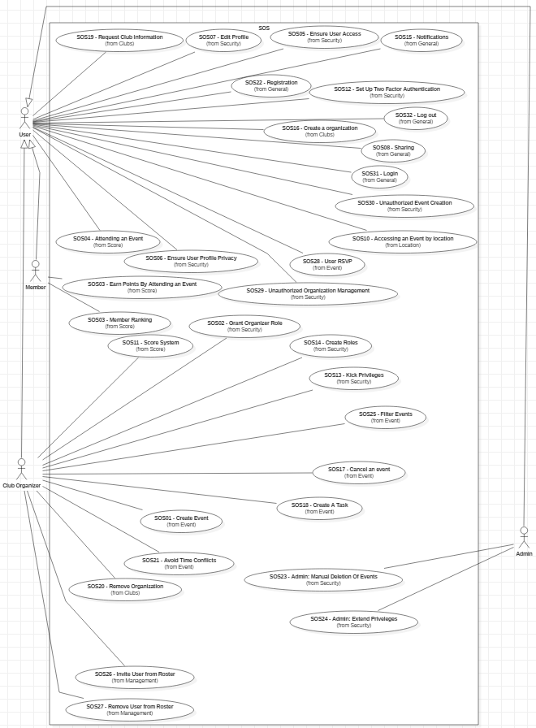

*Figure 1: Use Case diagram for the whole system.*

### Implemented Use Case Diagram

The following Use Cases are implemented:

* SOS01 – Create Event
* SOS02 – Grant Organizer Role
* SOS04 – Attending an Event
* SOS07 – Edit Profile
* SOS10 – Accessing an Event by Location
* SOS16 – Create an Organization
* SOS17 – Cancel an Event
* SOS22 – Registration
* SOS31 – Login
* SOS32 – Log Out

The Use Case diagram describing this subset is shown in .

*Figure 2: Use Case diagram for the implemented Use Cases.*

# Requirements Analysis

The following sections contain an Analysis model of the SOS system. Herein the expectations of the users for the system are defined. Section 5.1 contains scenarios instantiating each one of the implemented use cases. Each one of these scenarios has a corresponding object diagram and sequence diagram in Section 5.2. The object diagrams, together with a single class diagram, complete the static model of the system.

## Scenarios

Each of the following scenarios instantiates a corresponding use case from Section 4.1. The scenarios are further used in Section 5.2 to generate object diagrams for the static model. The more specific view of the system helps capture the actions and attributes of classes and objects that the SOS system must handle.

### Scenario: SOS16 - Creating an organization

A user named John Doe is logged into the system. John is on the organization page. John is part of no clubs but wants to create his own club. John attempts to create a club with the following parameters:

* Organization Name: “The Doe Crew”
* Organization Description: “A bunch of people excited for fishing.”
* Requirement for joining: “Anyone with an interest in fishing can join.”
* Privacy of the organization: PUBLIC

He submits his request and the page refreshes and shows him the newly created club with the parameters he provided.

### Scenario: SOS04 - Attending an event

A user named Patricio Clarke is logged into the system. Patricio is on the events page. Patricio is part of the organization “The Doe Crew” and the system provides a list of events that he has signed up for. The system shows one event called “Deep sea fishing.” Patricio is currently at the event and he decides to let the system know that he is at the event by clicking “I’m here.” After clicking on the button Patricio receives a message claiming that his attendance has been noted.

### Scenario: SOS14 - Registration

A user named John Day wants to join the SOS community. He enters the link to the log in page of the website and he clicks register and enters the following information:

* User Name = jday005
* Email = [jday005@fiu.edu](mailto:jday005@fiu.edu)
* Password = abc123
* Confirm Password = abc123

John clicks on register and the site then takes a couple of seconds to verify his registration. John is then sent to the home page.

### Scenario: SOS17 - Cancel an Event

An organizer named Juan Ciervo with event manager privileges is logged into the system and is in the event page. Juan sees all the events his organization is hosting which include “Hiking the Himalayas” and “Skydiving.” Juan Ciervo wants to cancel an the “Skydiving” event for his organization “The Ciervo Squad.” Juan clicks on view event description and then he clicks on cancel event. Juan is certain that the organization cannot host this event, so he confirms the cancellation request. Juan then sees that the event is no longer visible therefore it has been cancelled.

### Scenario: SOS31 – Log in

A user named Nica Perez is not logged into the system but has an account with the SOS. Nica is currently on the log in screen of the website and she puts in the following information into the log in form:

* Email: [npere203@fiu.edu](mailto:npere203@fiu.edu)
* Password: ***********

The system allows her to log in as her information is correct. She ends the scenario at the homepage.

### Scenario: SOS21 - Create Event

An organizer Mohammad Lee is logged into the system and he has event manager privileges. Mohammad is currently in the administration page of the organization he is a part of, “The Lees.” Mohammad wants to create an event, so he clicks on the create event button. A form appears and Mohammad inputs the following parameters:

* Event name: “Uphill biking”
* Event date and time: “10/05/2019 12:00:00 PM”
* Event location: “12345 SW 678 TER Kyoto, Japan 910112”
* Event Type: NORMAL
* Event Visibility: VISIBLE
* Event Duration: 1 hour

Mohammad publishes the new event he created, and the event is created successfully.

### Scenario: SOS02 - Grant Organizer Role

An organizer Juana Cierva is logged into the system and she has the role manager privilege. Juana is part of the organization “The Ciervo Squad.” Juana is currently on the organization management view. Juana want to grant a role to another member of “The Ciervo Squad,” Bob Swanson. Using the invitation menu Juana enters the following data:

* Member Name: “Bob Swanson”
* Organizer Title: “Moderator”
* Powers and Privileges: KICK

Juana submits the request to grant the role to Bob. Bob is then notified and Juana now sees that Bob owns the role of Moderator within “The Ciervo Squad.”

### Scenario: SOS07 - Edit Profile

A user Janet Lake is logged into the system and wants to change her account privacy. Janet clicks on the edit profile button and she sees the current profile settings she has on the page and is able to edit the following fields:

* Email: [jlake009@fiu.edu](mailto:jlake009@fiu.edu)
* Phone Number: (123) – 456-7890
* Privacy: Public

Janet changes her privacy to private and then submits the data. The page refreshes and shows a confirmation message displaying that her account is now private.

### Scenario: SOS32 – Log out

A user Bob Hope wants to log out of the system. He presses log out from the current page that he is in and he successfully logs out of the system.

### Scenario: SOS10 - Access Events by Location

A user Lolly Tates is logged into the system. Lolly is in the event page. Lolly allows the webpage to access her location (12345 SE 342 Ter 33029). After confirming, Lolly sees an event, “Volleyball tournament” occurring near her location.

## Static Model

This section contains the static view of the system described through UML object and class diagrams. In the static model, each entity (both external and internal) of the system is represented in terms of classes with attributes and operations, and their dependencies and associations. Two views are provided: the instantiated object diagrams, which are collected in Section 5.2.1, and the more general class diagram, which appears in Section 5.2.2.

### Object Diagrams

Each one of the UML object diagrams in this section is a subsection of the class diagram (in Section 5.2.2) which represents an instance of a Use Case (which can be seen in Section 4.1). The corresponding scenarios that the object diagrams are based on are in Section 5.1.

#### Object Diagram for Scenario: SOS16 – Create an Organization

The corresponding scenario for the object diagram in Figure 3 is in Section 5.1.1, which instantiates the Use Case in Section 4.1.2.16.

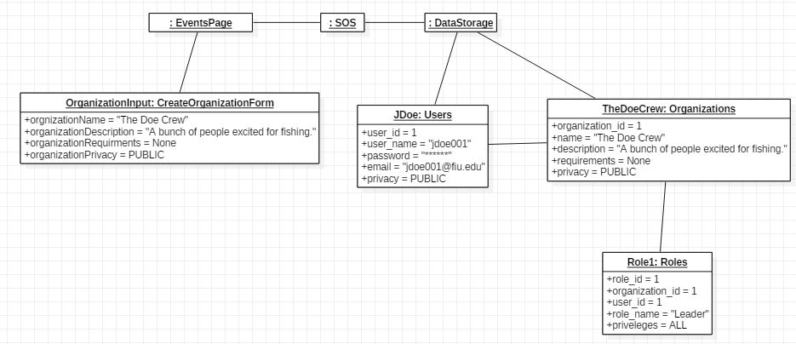

Figure : Object Diagram for Scenario: SOS16 - Create an Organization

#### Object Diagram for Scenario: SOS04 – Attending an Event

The corresponding scenario for the object diagram in Figure 4 is in Section 5.1.2, which instantiates the Use Case in Section 4.1.2.4.

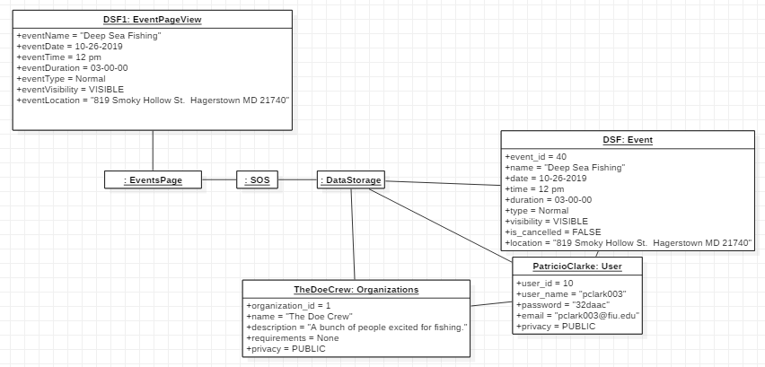

Figure : Object Diagram for Scenario: SOS04 - Attending an Event

#### Object Diagram for Scenario: SOS22 – Registration

The corresponding scenario for the object diagram in Figure 5 is in Section 5.1.3, which instantiates the Use Case in Section 4.1.2.22.

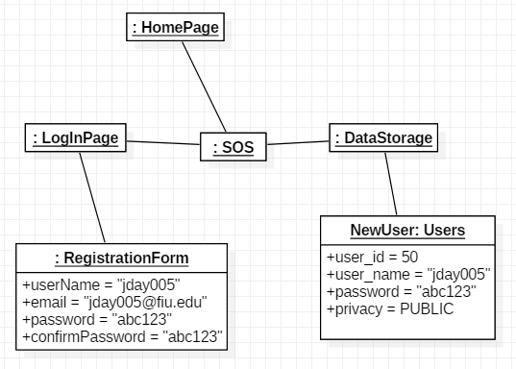

Figure : Object Diagram for Scenario: SOS22 – Registration

#### Object Diagram for Scenario: SOS17 – Cancel an Event

The corresponding scenario for the object diagram in Figure 6 is in Section 5.1.4, which instantiates the Use Case in Section 4.1.2.17.

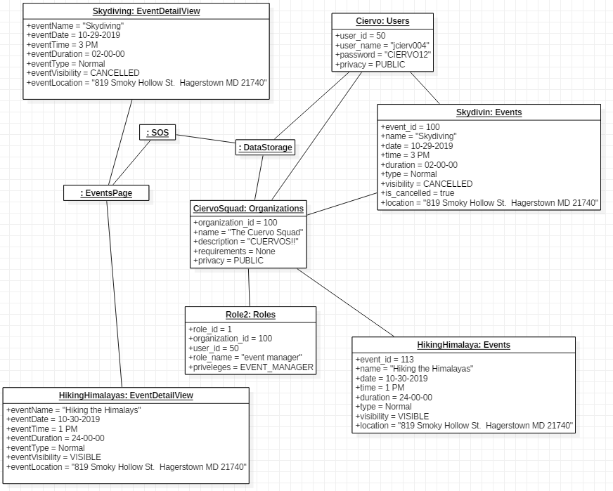

Figure : Object Diagram for Scenario: SOS17 – Cancel an Event

#### Object Diagram for Scenario: SOS31 – Log in

The corresponding scenario for the object diagram in Figure 7 is in Section 5.1.5, which instantiates the Use Case in Section 4.1.2.31.

|

|

|

Figure : Object Diagram for Scenario: SOS31 – Log in

#### Object Diagram for Scenario: SOS01 – Create Event

The corresponding scenario for the object diagram in Figure 8 is in Section 5.1.6, which instantiates the Use Case in Section 4.1.2.1.

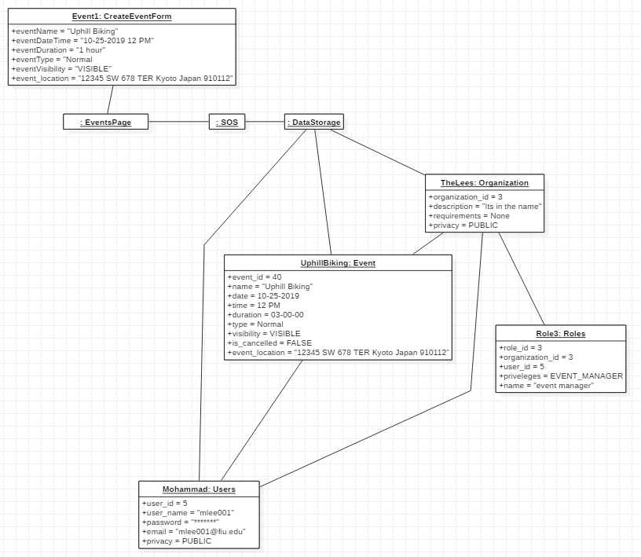

Figure : Object Diagram for Scenario: SOS01 – Create Event

#### Object Diagram for Scenario: SOS02 – Grant Organizer Role

The corresponding scenario for the object diagram in Figure 9 is in Section 5.1.7, which instantiates the Use Case in Section 4.1.2.2.

|

|  
|

|

Figure : Object Diagram for Scenario: SOS02 – Grant Organizer Role

#### Object Diagram for Scenario: SOS07 – Edit Profile

The corresponding scenario for the object diagram in Figure 5 is in Section 5.1.8, which instantiates the Use Case in Section 4.1.2.7.

|

|

|

Figure : Object Diagram for Scenario: SOS07 – Edit Profile

#### Object Diagram for Scenario: SOS32 – Log out

The corresponding scenario for the object diagram in Figure 11 is in Section 5.1.9, which instantiates the Use Case in Section 4.1.2.32.

|

|

|

Figure : Object Diagram for Scenario: SOS32 – Log out

#### Object Diagram for Scenario: SOS10 – Access Events by Location

The corresponding scenario for the object diagram in Figure 12 is in Section 5.1.10, which instantiates the Use Case in Section 4.1.2.10.

|

|

|

Figure : Object Diagram for Scenario: SOS14 – Registration

### Class Diagram

The class diagram for the system is depicted in Figure 13.

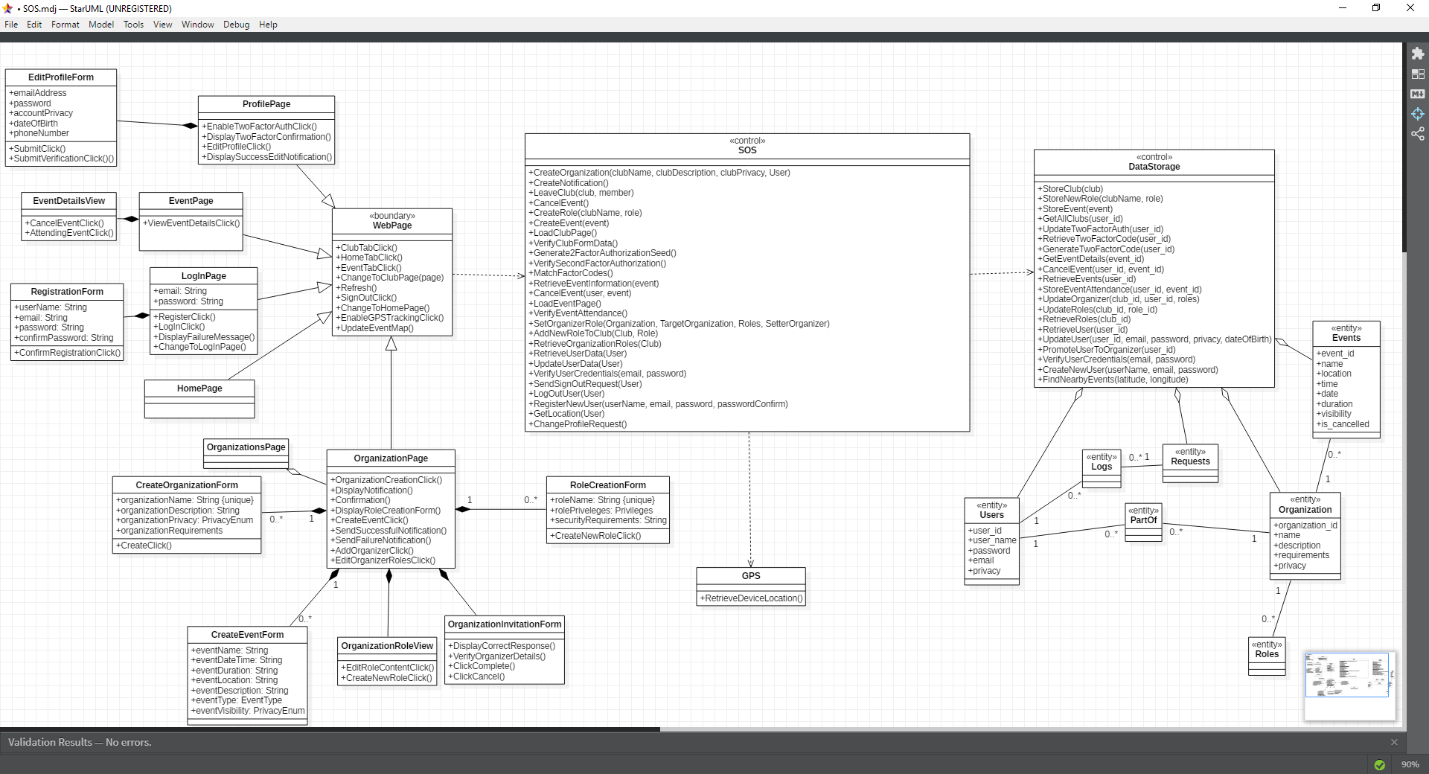

Figure : Class Diagram for the Implemented Use Cases

## Dynamic Model

Each one of the following sections contains a sequence diagram representing their associated Use Case.

### Sequence Diagram for SOS16 – Create an Organization

This sequence diagram in Figure 14 corresponds to the Use Case in Section 4.1.2.16.

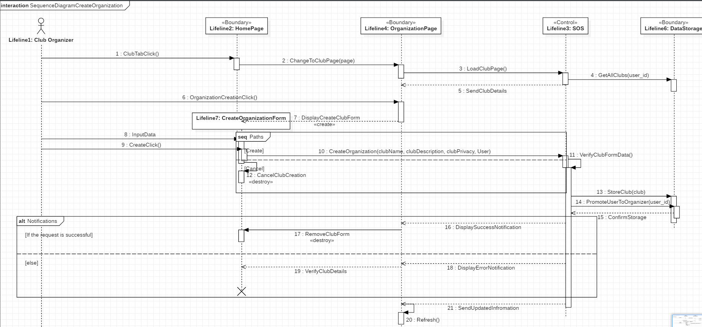

Figure : Sequence Diagram for SOS16 - Create an Organization

### Sequence Diagram for SOS01 – Create an Event

This sequence diagram in Figure 15 corresponds to the Use Case in Section 4.1.2.1.

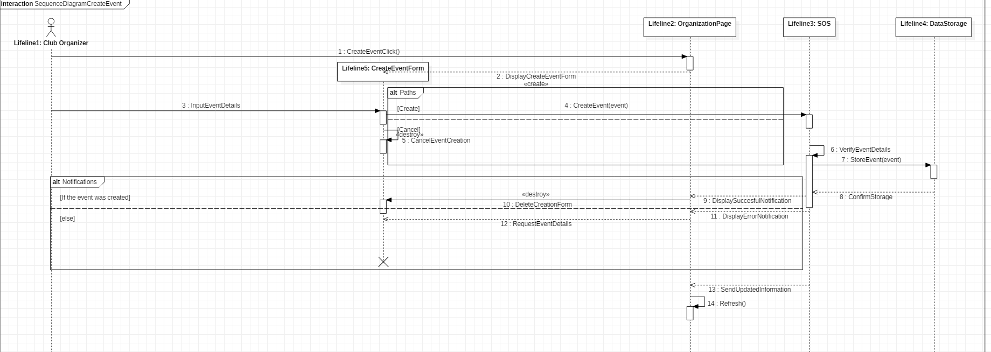

Figure : Sequence Diagram for SOS01 - Create Event

### Sequence Diagram for SOS17 – Cancel an Event

This sequence diagram in Figure 16 corresponds to the Use Case in Section 4.1.2.17.

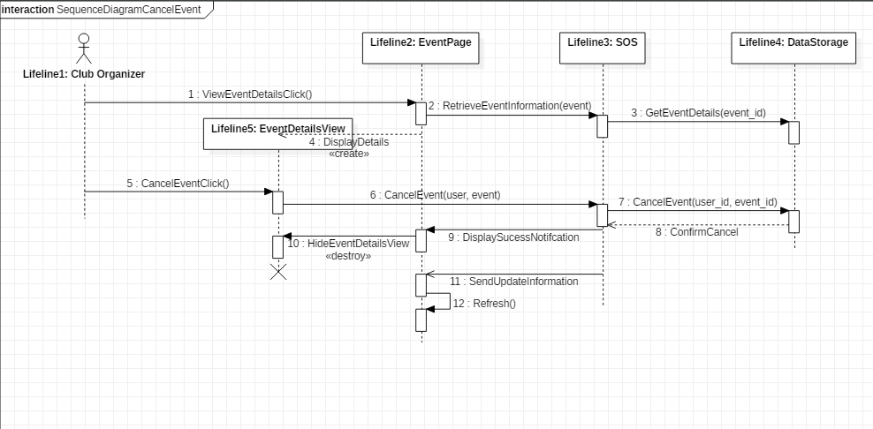

Figure : Sequence Diagram for SOS17 - Cancel an Event

### Sequence Diagram for SOS04 – Attending an Event

This sequence diagram in Figure 17 corresponds to the Use Case in Section 4.1.2.4.

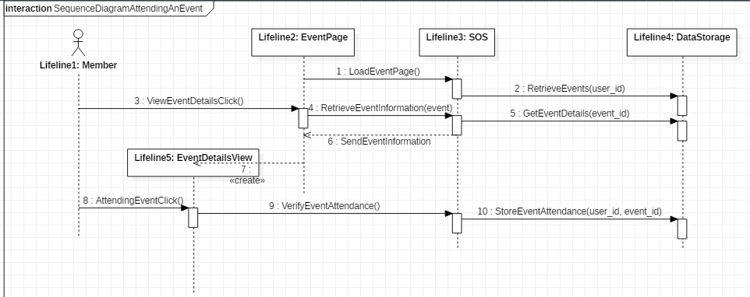

Figure : Sequence Diagram for SOS04 - Attending an Event

### Sequence Diagram for SOS02 – Grant Organizer Role

This sequence diagram in Figure 18 corresponds to the Use Case in Section 4.1.2.2.

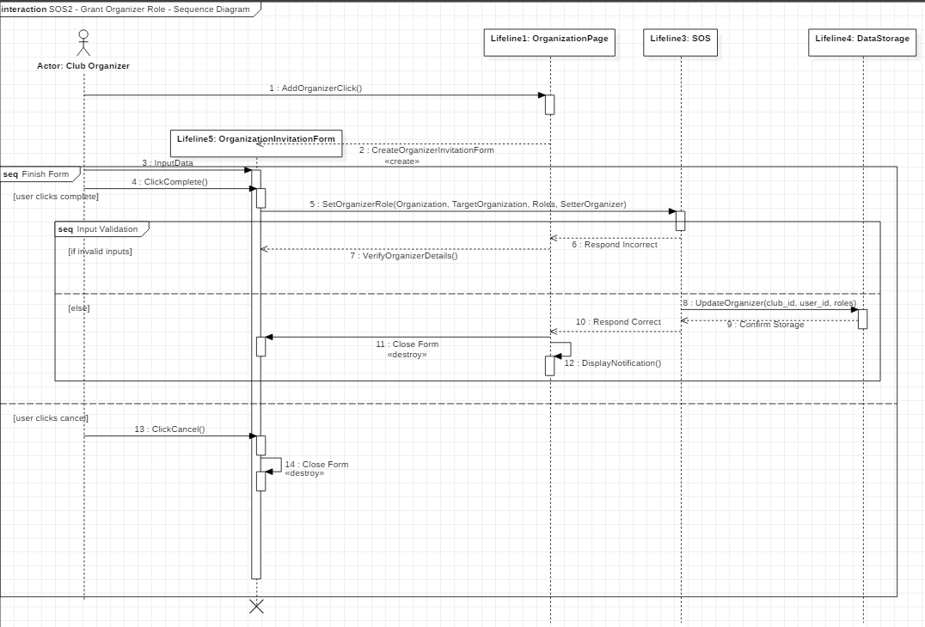

Figure : Sequence Diagram for SOS02 - Grant Organizer Role

### Sequence Diagram for SOS07 – Edit Profile

This sequence diagram in Figure 19 corresponds to the Use Case in Section 4.1.2.7.

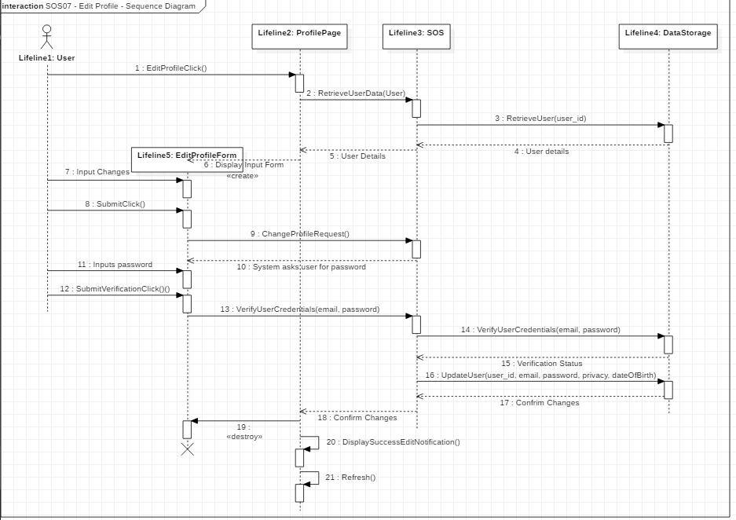

Figure : Sequence Diagram for SOS07 - Edit Profile

### Sequence Diagram for SOS10 – Accessing an Event by Location

This sequence diagram in Figure 20 corresponds to the Use Case in Section 4.1.2.10.

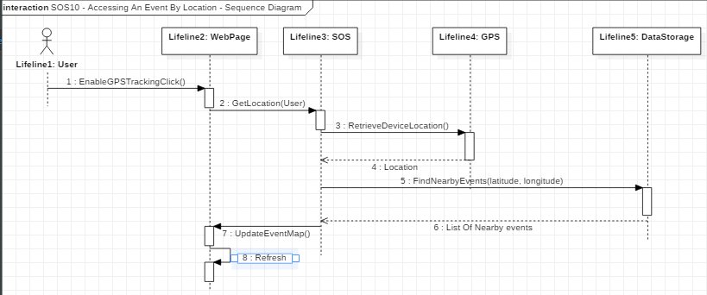

Figure : Sequence Diagram for SOS10 - Accessing an Event by Location

### Sequence Diagram for SOS22 – Registration

This sequence diagram in Figure 21 corresponds to the Use Case in Section 4.1.2.22.

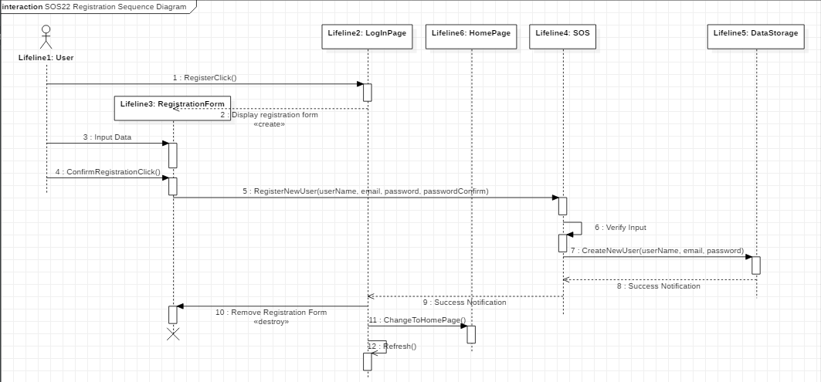

Figure : Sequence Diagram for SOS22 - Registration

### Sequence Diagram for SOS32 – Log Out

This sequence diagram in Figure 22 corresponds to the Use Case in Section 4.1.2.32.

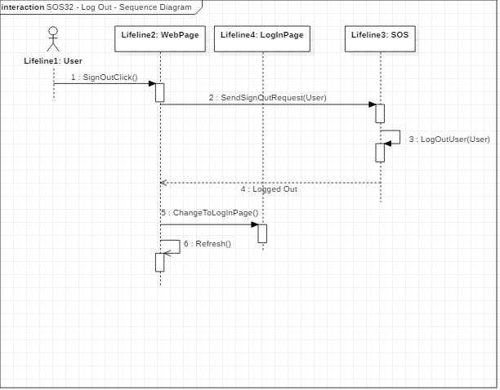

Figure : Sequence Diagram for SOS32 - Log Out

### Sequence Diagram for SOS31 – Log In

This sequence diagram in Figure 23 corresponds to the Use Case in Section 4.1.16.

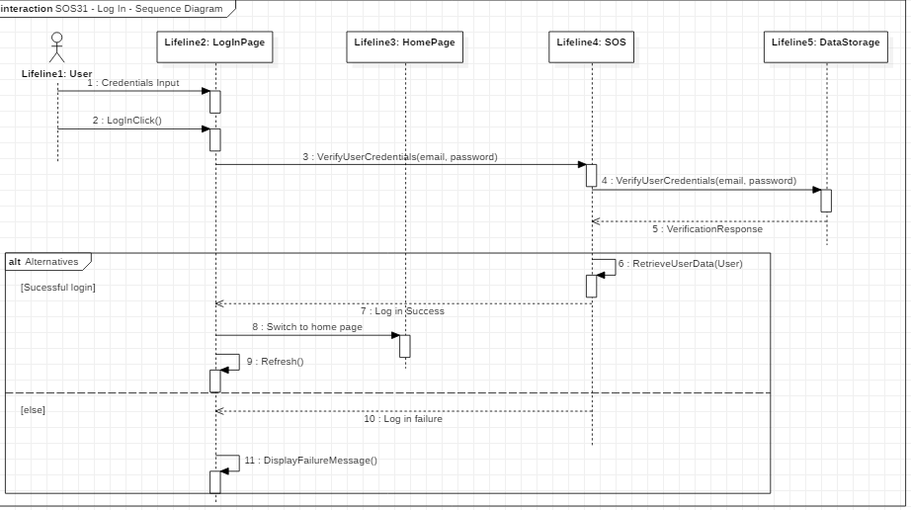

Figure : Sequence Diagram for SOS31 - Log In

# Glossary

* **Scenario**, a scene that illustrates some interactions of the proposed system.
* **Use Case**, …
* **Static Model**, …
* **Dynamic Model**, …
* **Unified Software Development Model**, …
* **Actors**
* **System**
* **Student Organization System**
* **Sequence Diagram**
* **Object Diagram**
* **Class Diagram**
* **Attribute**
* **Operation**
* **Task**

# Approval Page:

**Approval Page of System Requirements Document of**

**Student Organization System**

**Member Signatures**

___________________________________________ ________________________

Member Signature Date

___________________________________________ ________________________

Member Signature Date

___________________________________________ ________________________

Member Signature Date

___________________________________________ ________________________

Member Signature Date

___________________________________________ ________________________

Member Signature Date

___________________________________________ ________________________

Costumer Signature Date

# References

Campus Lab. (2019). *Panther Connect*. Retrieved from Panther Connect: https://fiu.campuslabs.com/engage/

Jacobson, I., Booch, G., & Rumbaugh, J. (1999). *The Unified Software Development Process.* Boston, MA, USA: Addison-Wesley Longman Publishing Co., Inc.

# Appendices

## Appendix A – Project Schedule

The scheduled tasks are contained in Section 3.3. The Gantt chart of the schedule is below, in Figure 24

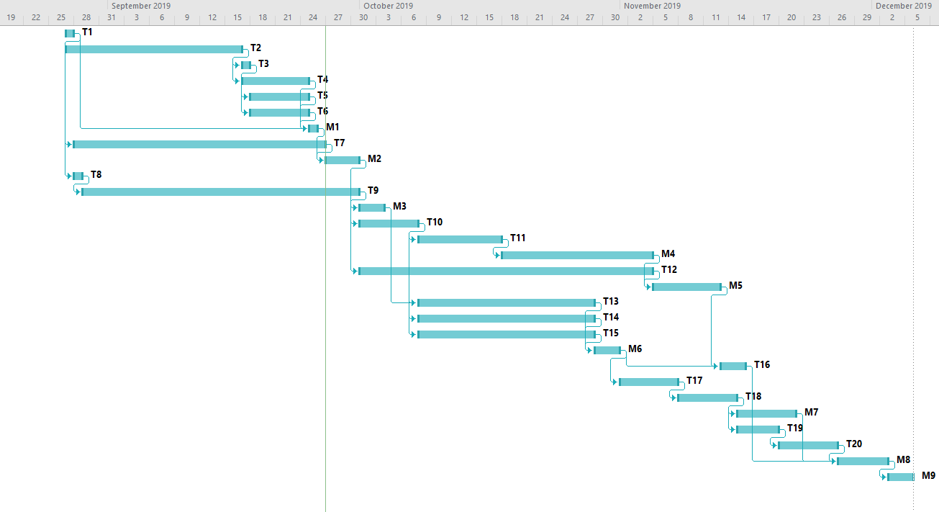

Figure : Gantt chart for the full project schedule.

## Appendix B

## Appendix C